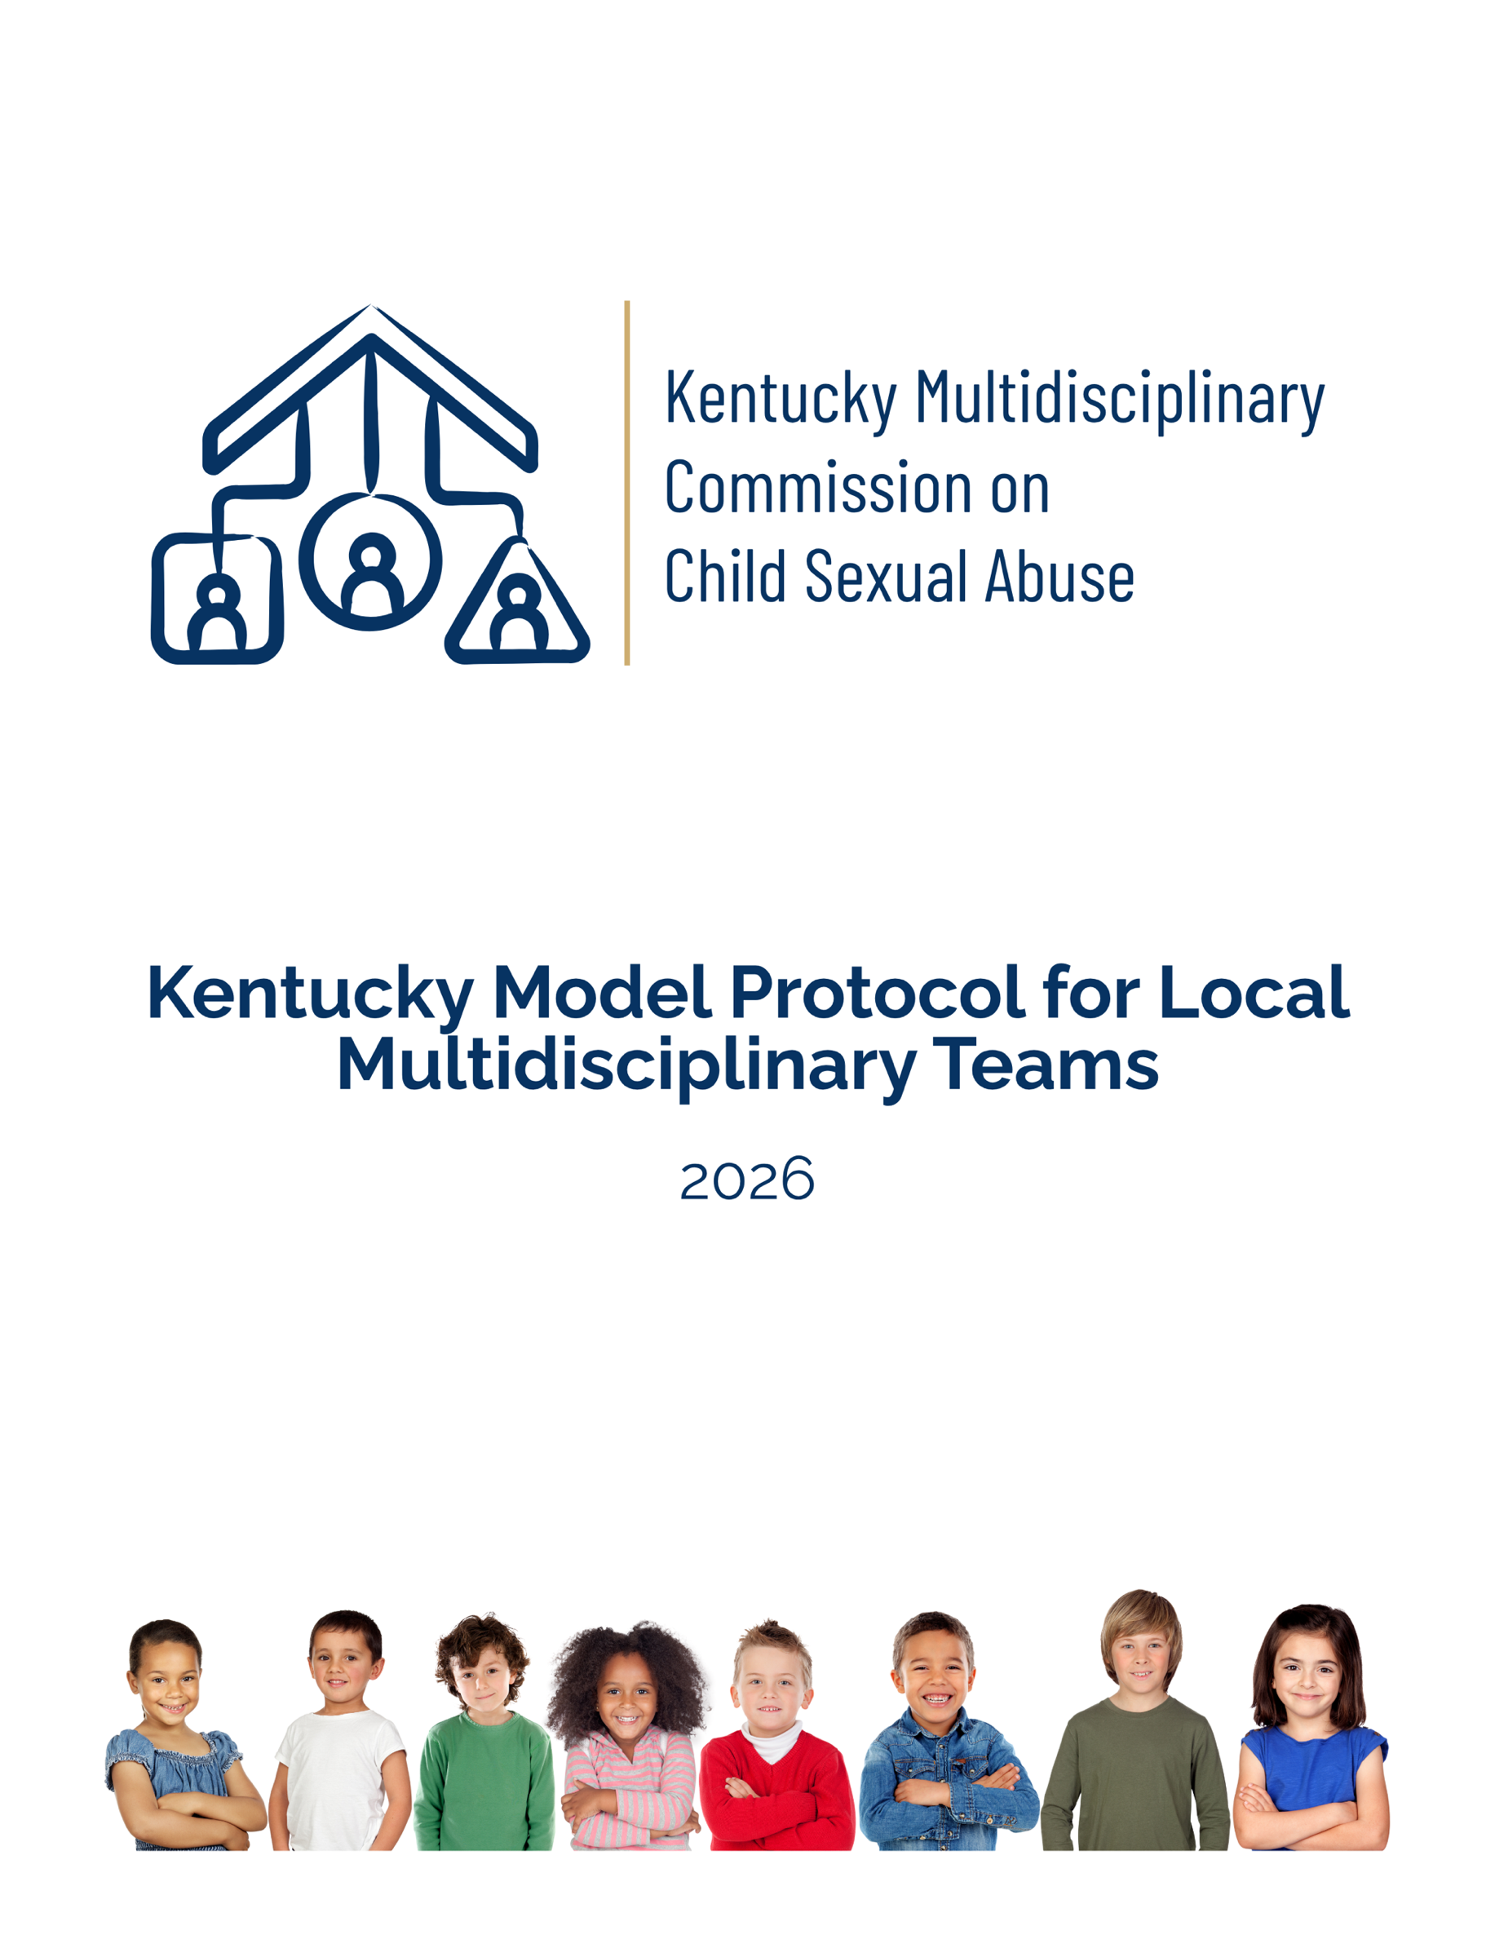
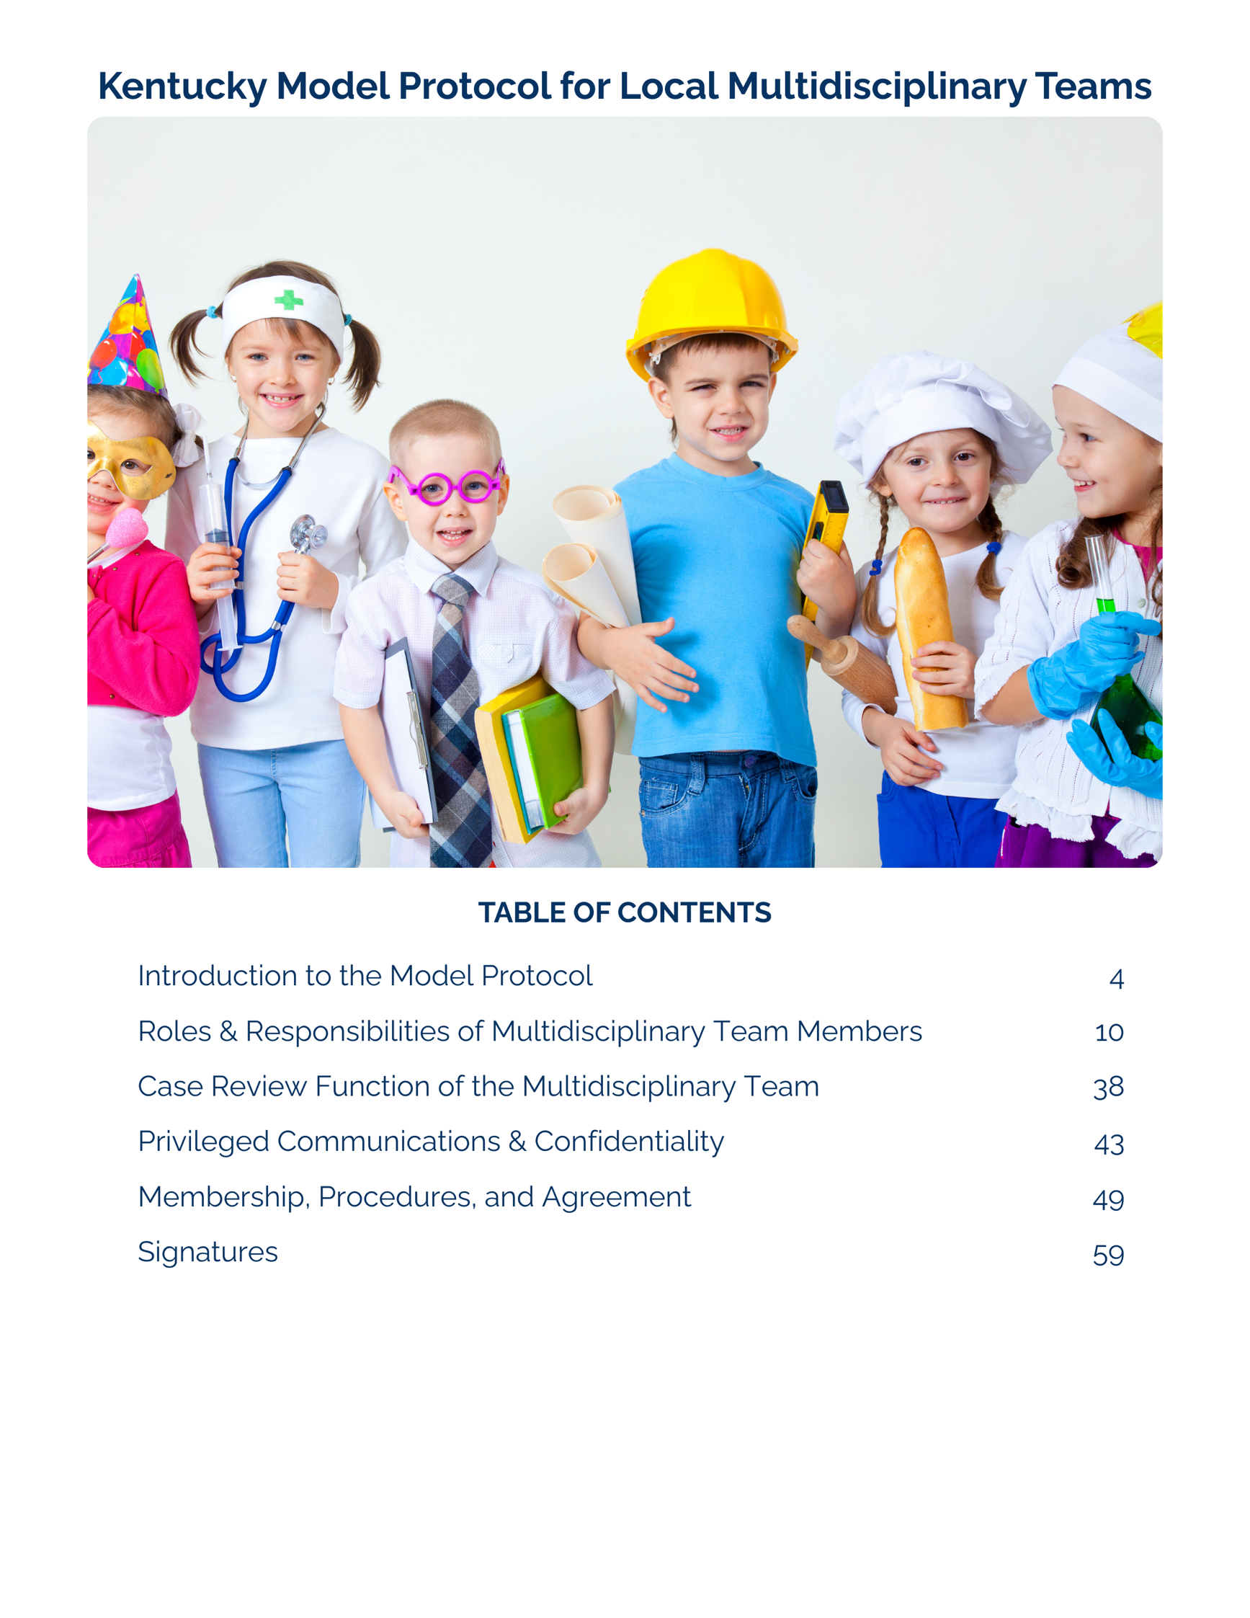
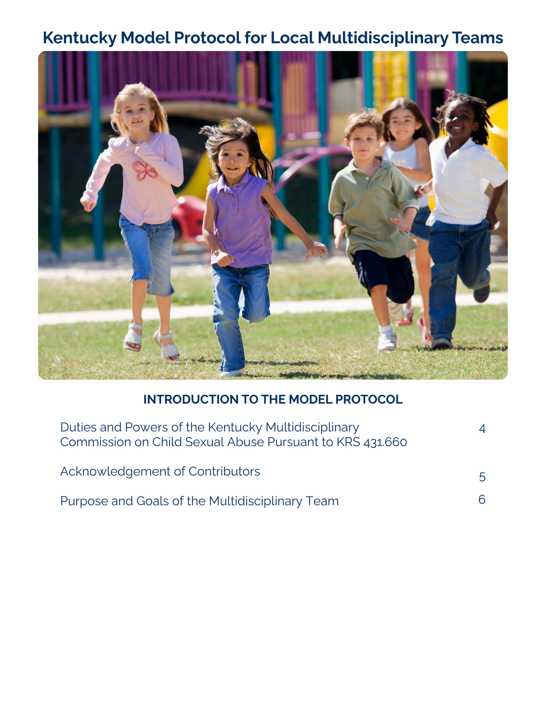

Introduction to the Model Protocol

The document that follows is intended to serve as the model for building local multidisciplinary teams in Kentucky. In addition to this model protocol, the Kentucky Multidisciplinary Commission on Child Sexual Abuse (“Commission”) has developed a local membership and procedures template to be completed by each team in Kentucky. The template outlines the information that each team needs to discuss and agree upon for the functioning of the local team and includes the required signature pages. Teams may choose to add sections to the template, subject to approval by the Commission, however nothing from the model protocol nor the template may be deleted. Local protocols shall be approved by the Commission.

Local multidisciplinary teams should review the Model Protocol and Local Agreement annually and obtain new signatures when there is a change in practice, a change in leadership, or every three years. For changes in leadership, only the new leader’s signature is needed if no changes have been made to the Local Agreement.
Duties and Powers of the Kentucky Multidisciplinary Commission on
Child Sexual Abuse Pursuant to KRS 431.660
- Prepare and issue a model protocol for local multidisciplinary teams regarding investigation and prosecution of child sexual abuse and the role of children's advocacy centers on multidisciplinary teams.
- Review and approve protocols prepared by local multidisciplinary teams.
- Advise local multidisciplinary teams on the investigation and prosecution of child sexual abuse.
- Receive data on child sexual abuse cases collected by the Prosecutors Advisory Council and issue annual reports.
- Collect data on the operation of local multidisciplinary teams.
- Seek funding to support special projects relating to the operation of local multidisciplinary teams.
- Receive and review complaints regarding local multidisciplinary teams and make appropriate recommendations.
- Recommend to the Governor, Legislative Research Commission, and Supreme Court changes in state programs, legislation, administrative regulations, policies, budgets, and treatment and service standards which may facilitate effective intervention of child sexual abuse cases and the investigation and prosecution of perpetrators of child sexual abuse, and which may improve the opportunity for victims of child sexual abuse to receive treatment.

Acknowledgement of Contributors

Thank you to members of the Commission and other professionals who contributed to the development of this protocol and local membership and procedures template:
Members of the Kentucky Multidisciplinary Commission on Child Sexual Abuse

Melanie Taylor - Designee for the Department for Community Based Services
Brittany Barber - Designee for the Department of Behavioral Health, Developmental and Intellectual Disabilities
Jessica Jones - Social Worker employed by the Department for Community Based Services, appointed by the secretary of the Cabinet for Health and Family Services
Susan Heffner Rhema, PhD, LCSW - Therapist appointed by the secretary of the Cabinet for Health and Family Services
Capt. Jeremy Smith - Designee for the Department of the Kentucky State Police
Sgt. Elizabeth Brushway - Law Enforcement Officer appointed by secretary of the Justice and Public Safety Cabinet
Dolores Smith - Employee of the Administrative Office of the Courts appointed by the Chief Justice of the Supreme Court of Kentucky
R. Ramsey Dallam - Employee of the Office of the Attorney General appointed by the Attorney General
Erica Paske - Employee of the Office of the Attorney General appointed by the Attorney General
Rob Sanders - Commonwealth Attorney appointed by the Attorney General
Christina Weeter, MSW, MEd - Designee for the Department of Education
Shericka D. Smith, MSSW, CSW - School counselor representative appointed by the commissioner of the Department of Education
Caroline Ruschell - Representative of a Children’s Advocacy Center appointed by the Governor
Jacqueline Sugarman, MD, FAAP - Physician appointed by the Governor
Trena Floyd - Appointee representing survivors appointed by the Attorney General

Additional contributors
Denise Durbin, Office of the Attorney General
Serah Wiedenhoefer, Office of the Attorney General
Jackie Kuryla, Children’s Advocacy Centers of Kentucky
Laura Kretzer, Children’s Advocacy Centers of Kentucky

Purpose And Goals of the Multidisciplinary Team

The purpose of the local multidisciplinary team (MDT) shall be to review investigations, assess service delivery, and facilitate efficient and appropriate disposition of cases through the criminal justice system.

Local MDTs shall respond to and review, at a minimum, all the cases meeting the following criteria:
- reported or suspected child sexual abuse cases
- child human trafficking cases involving commercial sexual activity referred by participating professionals, including those in which the alleged perpetrator does not have custodial control or supervision of the child or is not responsible for the child’s welfare
- reported or suspected female genital mutilation cases

In Kentucky, the following agencies may receive reports of abuse: local law enforcement, the Kentucky State Police, the Cabinet for Health and Family Services, Commonwealth’s Attorneys, and County Attorneys. Each agency is responsible for ensuring that any report of suspected child sexual abuse made directly to that agency is handled in accordance with the procedures outlined in KRS 431.600(1), KRS 620.040(8)(c), and this protocol.

For purposes of this protocol, reported or suspected child sexual abuse is defined as
- a report accepted by the Department for Community Based Services (DCBS) Centralized Intake for an investigation or alternative response to child sexual abuse (including sexual exploitation), human trafficking involving commercial sexual exploitation, or female genital mutilation, as defined in the DCBS Structured Decision-Making Model and Standards of Practice
- a report that is received by any investigative agency that identifies a suspected sexual crime against a child, even if that allegation appears alongside other forms of abuse. Sexual crimes against children include, but are not limited to
  - rape
  - incest
  - sodomy
  - sexual extortion
  - use of a minor in a sexual performance and related exploitation offenses
  - sexual abuse
  - indecent exposure
  - unlawful Transaction with a Minor in the First Degree
  - unlawful use of electronic means originating or received within the Commonwealth to induce a minor to engage in sexual or other prohibited activities
  - possession of matter portraying a sexual performance by a minor or distribution of matter portraying a sexual performance when there is a known victim

The remainder of this document applies to the above identified cases when referencing child victims of abuse/abused children. Local teams may identify additional criteria for team response and children’s advocacy center services and document these in the provided local membership and procedures template. Teams are encouraged to include near fatalities and fatalities involving physical abuse and related witnesses in their local agreements.

The MDT is committed to serving all children and families who meet the above identified case criteria and does not discriminate based on any legally protected class.

The multidisciplinary team approach allows for a coordinated response to child abuse and creates a system of investigation and prosecution that minimizes trauma for children and their families. Local MDTs have the following goals: (1) safety and protection for child victims of abuse and (2) accountability of the child abuse service system.

GOAL: Safety and Protection for Child Victims of Abuse
- ensure the safety of the child victim and to minimize further trauma or systemic revictimization;
- facilitate successful outcomes in both the child protection and criminal justice systems through effective, collaborative fact finding and coordinated case development;
- minimize revictimization and improve outcomes for child victims and protective family members throughout the investigation, assessment, intervention, and prosecution processes;
- minimize the number of victim interviews and to ensure interagency collaboration;
- facilitate access to medical and mental health intervention to promote successful healing; and
- protect the privacy rights of the child and the child's family to the fullest extent possible

GOAL: Accountability of the Child Abuse Service System
- increase the quality of child abuse investigations, prosecution, and victim services and eliminate the duplication of efforts;
- increase successful prosecution and offender accountability through multidisciplinary collaboration;
- ensure that each case of child abuse is appropriately reviewed;
- hold all professionals involved in child abuse cases to the highest standard of professional conduct;
- ensure best practice care guidelines are implemented throughout the system of care;
- identify and improve system and local resource deficiencies;
- promote child victim and family voice;
- collect and maintain accurate information regarding the investigation and prosecution of child abuse cases;
- implement trauma-informed-care practices and principles; and
- increase and maintain active participation and consistent attendance of each agency and discipline at multidisciplinary team case review meetings.

Roles and Key Responsibilities of Multidisciplinary Team Members

A multidisciplinary team includes professionals from a myriad of relevant disciplines who collaborate from the point of report throughout a child and family’s involvement with an investigation and when applicable, with the criminal justice system. Multidisciplinary teams coordinate investigations and service delivery to maintain open lines of communication, promote transparency, foster trust, and help optimize a high-quality response while preserving and respecting the rights of the clients and the respective mandates of each member agency.

Local MDT members include representatives from government agencies tasked with investigating crimes against children, alongside organizations and private practitioners who provide protective services and therapeutic support to children within the community. The local MDT consists of, at a minimum, law enforcement officers, social workers from the Department for Community Based Services (DCBS), prosecutors, child advocacy center (CAC) staff, mental health providers, victim advocates, and medical professionals. Local MDTs may be expanded to include education system representatives. Local MDTs may also expand to include other relevant professionals as deemed necessary and appropriate for an individual child, family, or community on a case-by-case or routine basis.
Local Multidisciplinary Team members are defined as:
- a professional employed by an agency that has signed the multidisciplinary team protocol in effect for the multidisciplinary team; and
- a professional who is actively involved in the child abuse service system.

Key Responsibilities Common to All Team Members
- operate in the best interest of the child;
- educate team members on the role of each discipline represented;
- attend case review meetings and actively participate in the team's activities;
- work and communicate in a cooperative manner with other members on the multidisciplinary team, while maintaining the privacy interests of the child and the confidentiality of the case review process; and
- report any significant developments in the case to appropriate agencies (law enforcement agencies, Department for Community Based Services, prosecutors) and the multidisciplinary team including by making a new report of abuse or neglect when applicable.

Prosecuting Attorneys

Commonwealth’s Attorney
The Commonwealth's Attorney prosecutes all felony crimes (those offenses carrying a penalty of one year or more and misdemeanors attached to felony offenses) committed by persons eighteen years of age or older, which occur in the judicial circuit of that jurisdiction. In some specific instances, the Commonwealth's Attorney may also prosecute juveniles charged with felony offenses. The Commonwealth's attorney is responsible for presenting evidence of such crimes to the grand jury.

County Attorney
The County Attorney prosecutes crimes committed within the county and that are within the jurisdiction of the district court. These cases include felony crimes through preliminary hearing, misdemeanor offenses, crimes committed by juveniles, and dependency, neglect, and abuse cases.

Specific responsibilities of the Commonwealth and County prosecuting attorneys relating to child abuse cases:
- assist any multidisciplinary team established within their judicial circuit or county.Assistance may include, but is not limited to, facilitating case review and providing information regarding evidentiary issues, trial procedure, case status and disposition.
- participate as members of the local multidisciplinary team and shall attend case review meetings of the team. Non-attorneys are not adequate substitutes for the role of the prosecutor.
- provide any data requested by the Prosecutors Advisory Council;
- employ a child sexual abuse specialist, if adequate personnel are available;
- take an active part in interviewing and familiarizing the child alleged to have been abused, or who is testifying as a witness, with the proceedings throughout the case, beginning as early as practicable in the case. Prosecutors are encouraged to attend the forensic interview at the children’s advocacy center when possible.
- provide for an arrangement which allows one lead prosecutor to handle the case from inception to completion in order to minimize the number of persons involved with the child victim, if adequate staffing permits;
- minimize the involvement of the child in legal proceedings, avoiding appearances at preliminary hearings, grand jury hearings, and other proceedings when possible;
- make appropriate referrals for counseling, private legal services, and other appropriate services to ensure the future protection of the child when a decision is made not to prosecute the case;
- explain the decision not to prosecute to the family or guardian, as appropriate, and to the child victim. This responsibility does not apply to the Commonwealth’s attorney or county attorney if the decision not to refer the case for prosecution is made by law enforcement.
- consider the impact of legal system delays on victims;
- retain decision-making authority regarding the disposition of criminal cases. The decision to proceed by trial or guilty plea, to amend or to dismiss charges, to make sentencing recommendations as to term of years, concurrent or consecutive sentencing, or probation, shall be made by the prosecuting attorney. While the Commonwealth's and county attorneys have ultimate decision-making authority regarding the disposition of criminal cases, the victim shall be consulted by the prosecutor for the Commonwealth on the disposition of the case, including dismissal, release of the defendant pending judicial proceedings, any conditions of release, a negotiated plea, and entry into a pretrial diversion program. It is recommended that the prosecutor consider input from the team in making these decisions.
- notify the victim that, upon conviction of the defendant, the victim has the right to submit a written victim impact statement to the probation officer responsible for preparing the presentence investigation report for inclusion in the report or to the court should such a report be waived by the defendant;
- provide information to victims and witnesses on how they may be protected from intimidation, harassment, and retaliation; and
- make a reasonable effort to ensure that victims are afforded their constitutional and statutory rights.

Additional specific roles of the County Attorney:
- The county attorney has a critical role in the handling of dependency, neglect, and abuse cases in juvenile court which is a primary source of protection for abused children.
- County attorneys should establish procedures for the exchange of information on cases of dependency, neglect, and abuse with the Department of Community Based Services (DCBS). These procedures may be adapted to the size of the county or circuit, and the resulting caseload may include asking for written reports from the DCBS workers and convening meetings on a regularly scheduled basis.

Joint Investigation by the Department for Community Based Services and Law Enforcement

DCBS and law enforcement shall participate in the joint investigation of all child sexual abuse cases. The Children’s Advocacy Center assists in the coordination of the investigation of child abuse by providing a location for forensic interviews and medical examinations and by promoting the coordination of services for children alleged to have been abused.

Specific responsibilities are shared through this joint investigation process, including presenting cases to the MDT for case review.
Kentucky’s DCBS utilizes a statewide intake data system and provides children’s advocacy centers with access to certain intake reports that may meet criteria for the MDT response. This access is referred to as the Multidisciplinary Enhancement Program (MEP).

With MEP, the CAC | MEP does not change the
- serves as safety net in catching cases that could benefit from a collaborative team approach that MEP offers;  - assists in connecting child protective services and law enforcement for launch of joint investigation/ MDT response;  - assists with timely scheduling of CAC services, as per agreed upon criteria in the protocol; and  - will analyze data from reports to assist communities and MDTs in identifying needs and gaps. | - responsibility for review of Central Intake reports by law enforcement;  - responsibility for law enforcement and child protective services investigators to initiate joint investigation, contact the CAC, and refer cases for MDT response per local protocol;  - role and authority of CAC or community partner agencies; and  - criteria for MDT response, although review by the team of the protocol for agreement and clarity is encouraged.

Interviewing Victims:
- Given that interviewing the alleged victim is a key component of an investigation of child sexual abuse, DCBS and law enforcement shall both participate in the interviewing process. Multiple interviews of the child victim present challenges in later litigation.
- Every effort should be made to conduct interviews at the Children’s Advocacy Center.
- A forensic interview provides for an in-depth line of questioning in a safe, neutral environment.
- The needs of the child should be considered in scheduling the forensic interview in order to gather information in a timely manner and minimize outside influence on the child and his or her disclosure.

Out of Jurisdiction Interviews
- Occasionally, child victim interviews may need to be conducted by a child advocacy center outside of the multidisciplinary team’s case jurisdiction in order for the best interest of the child to be protected. These referrals are considered courtesy services by child advocacy centers with priority consideration given to geographic accessibility for the child and family; in the event they do not reside in the area of case jurisdiction. Coordination of those referrals is facilitated by the child advocacy center representing the case jurisdiction.
- Law enforcement and child protection services must be present at courtesy forensic interviews, as appropriate to the case, to provide real time observation and participation in pre- and post-interview meetings. In rare circumstances when law enforcement or child protection services multidisciplinary team members with jurisdiction are unable to attend, those agencies should coordinate the presence of law enforcement and child protection services representatives from the jurisdiction in which the child resides or the jurisdiction of the child advocacy center conducting the courtesy interview.

Interviewing Caregivers, Alleged Offenders and Witnesses:

In the course of the investigation, DCBS and law enforcement will conduct a joint investigation to coordinate the interviewing of parents/caregivers (non-offending), alleged offenders, and any witnesses to the offense(s).

Obtaining Medical Care

The following charts are provided to assist investigators in determining the need for, timing of, and provider of medical care related to child sexual abuse reports.
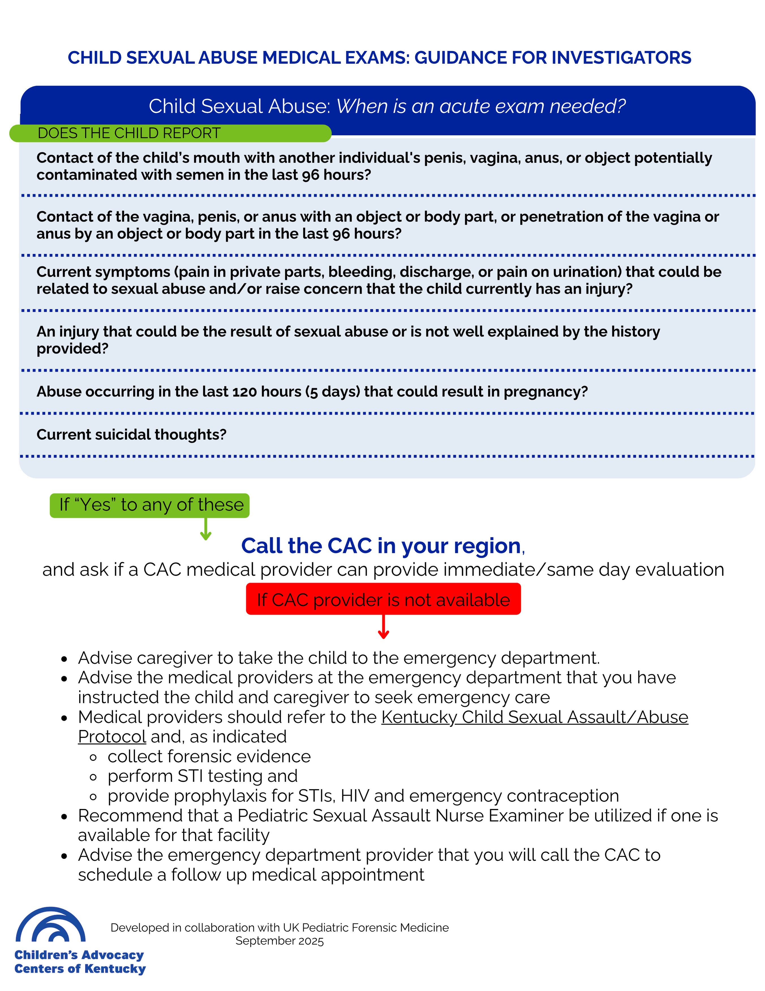
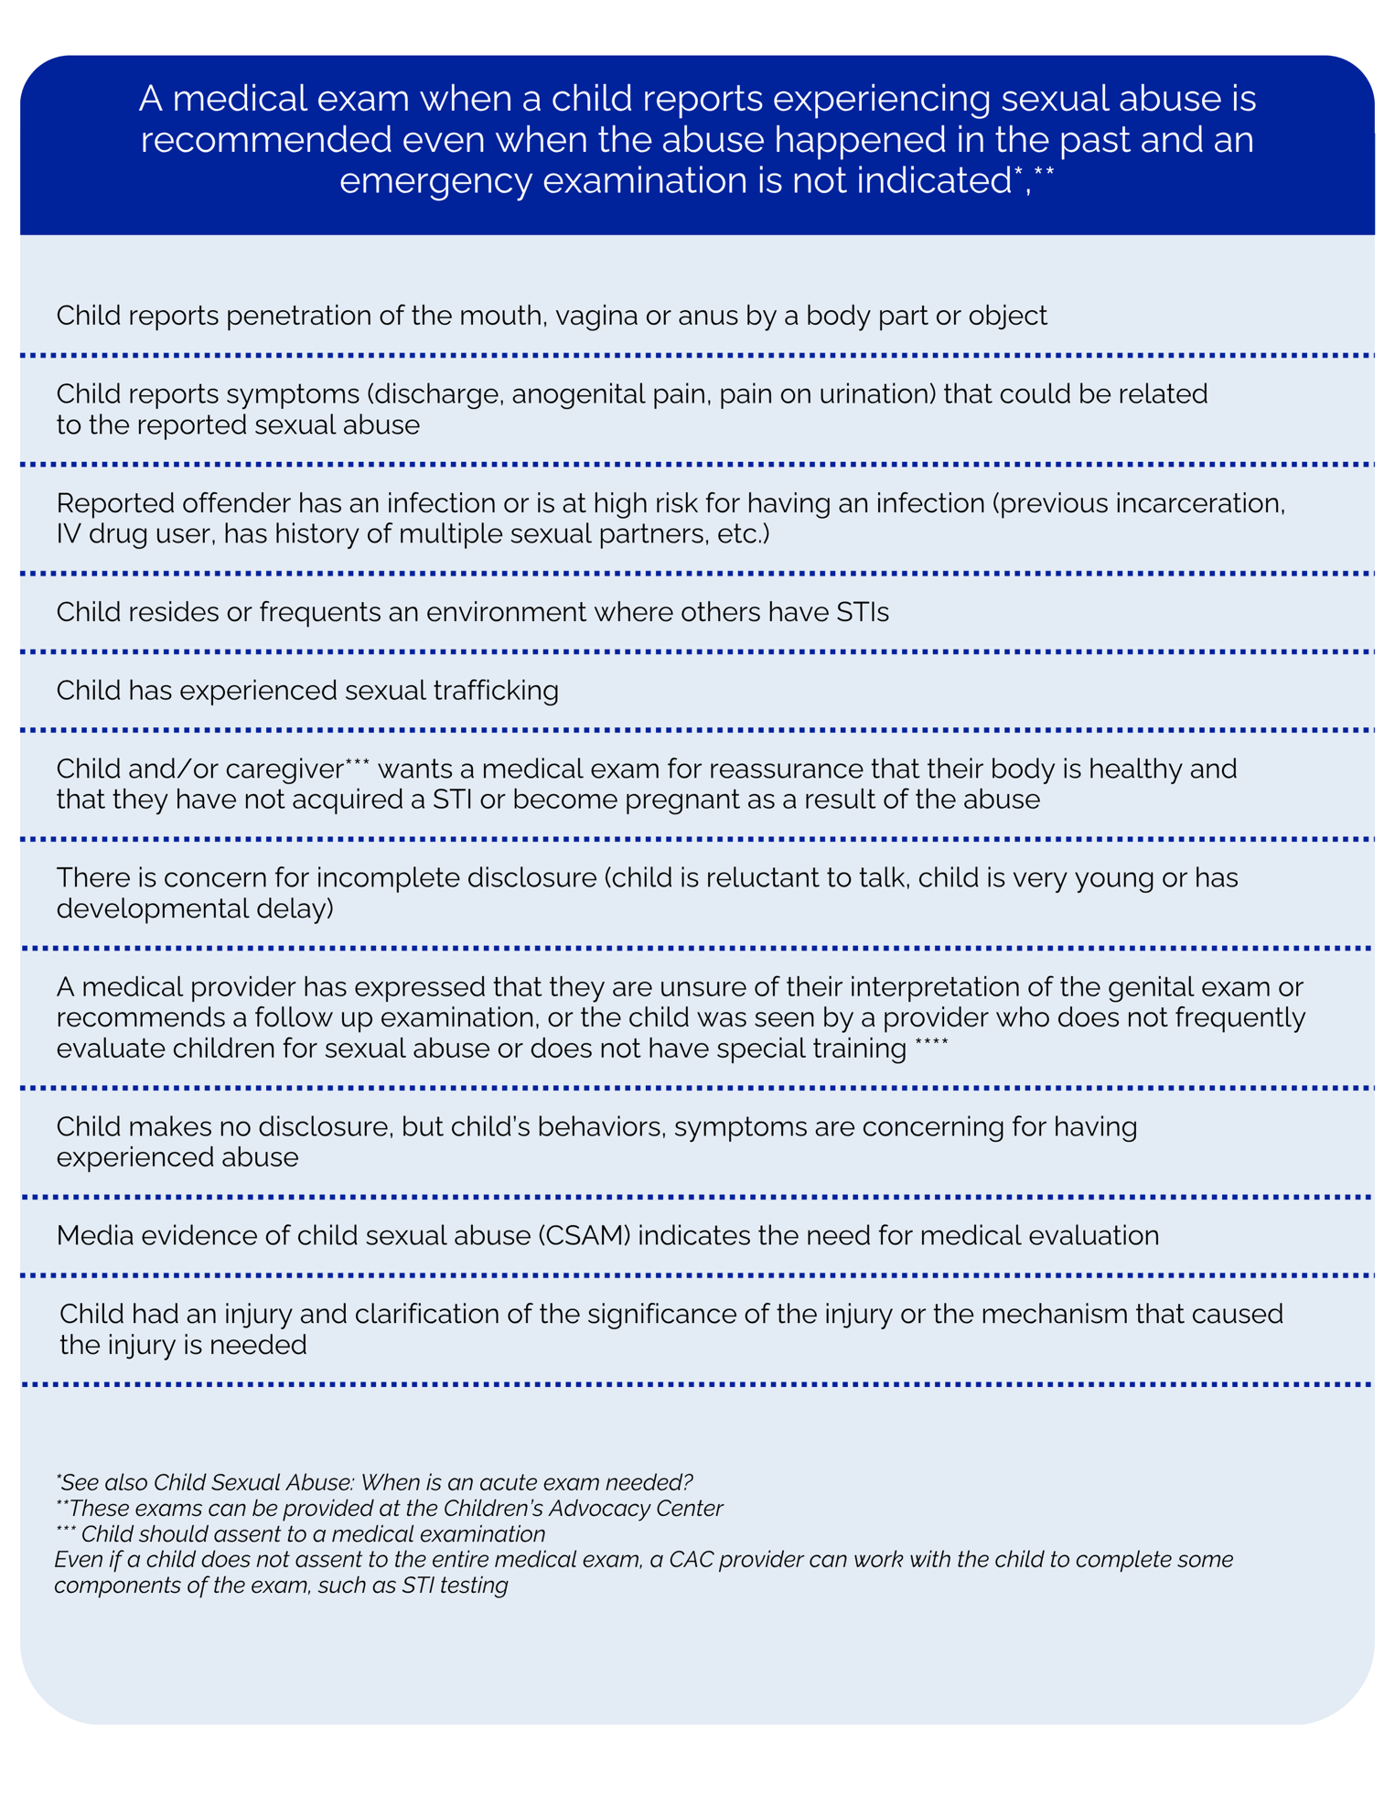
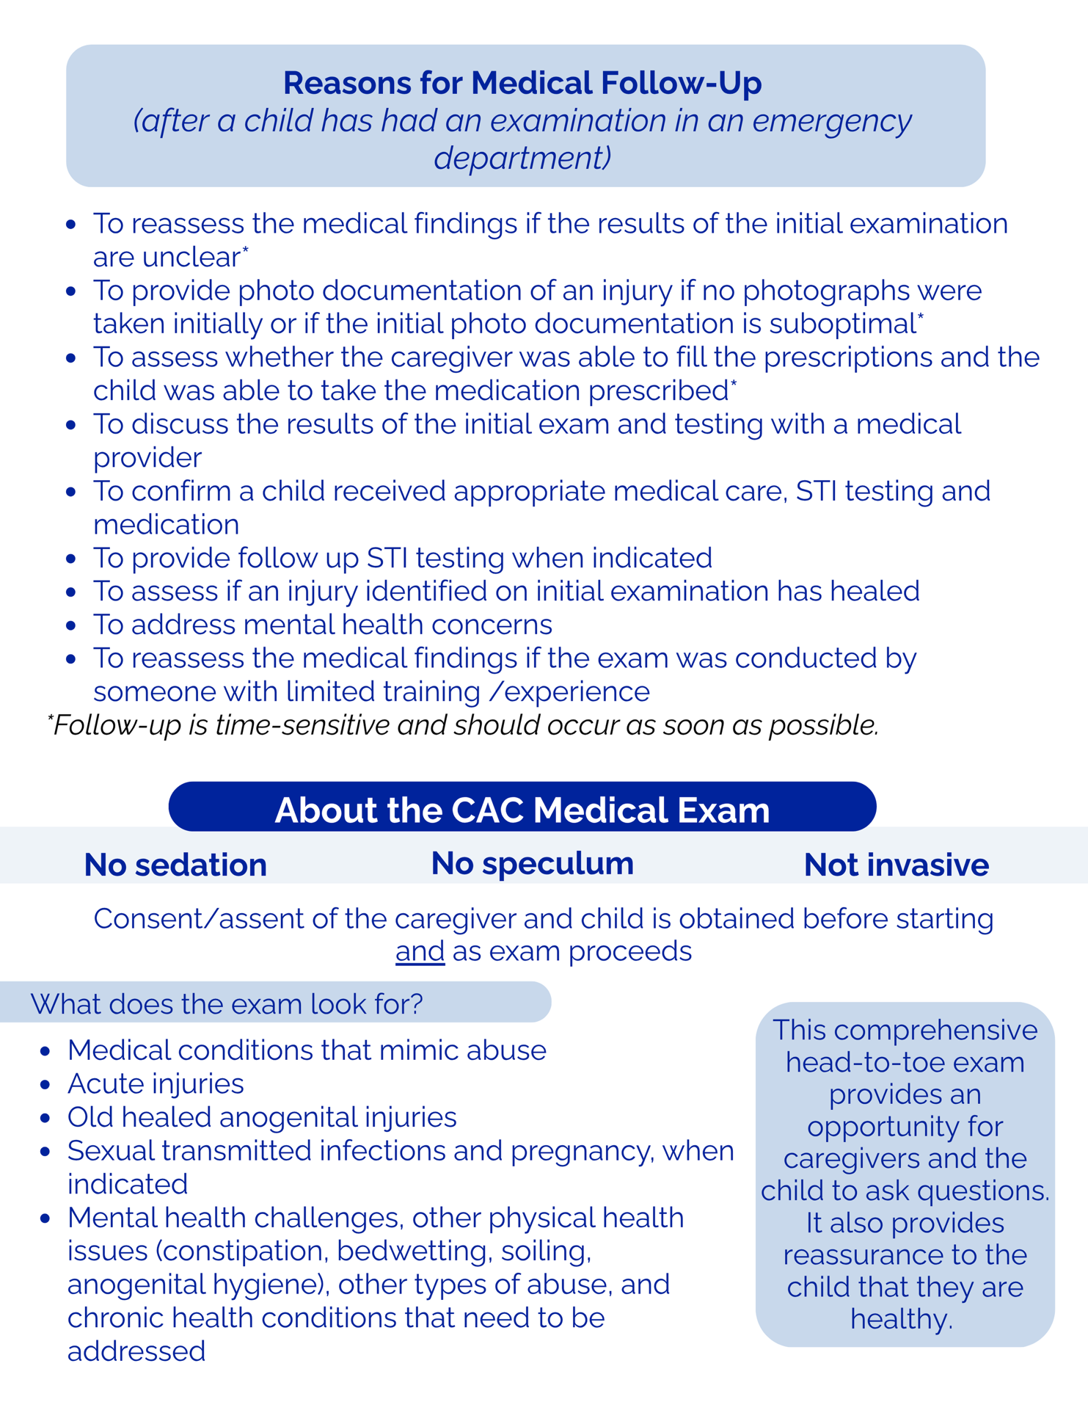
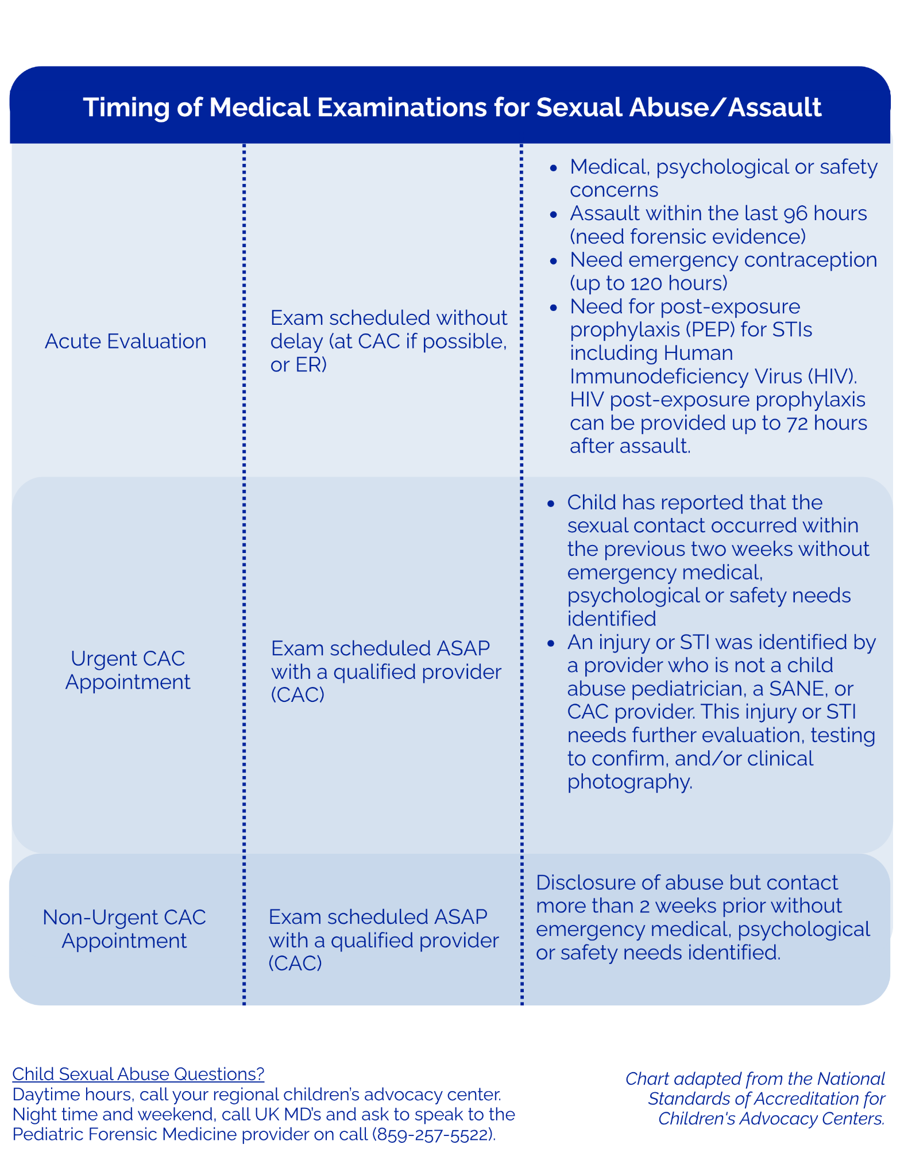

Department for Community Based Services (DCBS)

The responsibilities of DCBS workers are outlined in both the KRS and the internal policies of the Cabinet for Health and Family Services (CHFS or Cabinet). DCBS shall participate, along with law enforcement, in the joint investigation of all child sexual abuse cases.

Specific responsibilities of DCBS relating to child abuse cases:
- immediately investigate all reports of child abuse or neglect in which the alleged perpetrator was in a caretaking role and all reports alleging a child is a victim of human trafficking. Within 72 hours of receipt of the allegation, DCBS shall make a written report to the prosecutor and local law enforcement or the Kentucky State Police. DCBS shall serve as lead investigators only in those cases of reported or suspected sexual abuse of a child in which a person exercising custodial control or supervision is the alleged or suspected perpetrator of the abuse.
- assist law enforcement in investigations of noncustodial abuse;
- participate in all investigations of reported or suspected sexual abuse or human trafficking of a child;
- DCBS social workers and/or supervisors with knowledge of the cases shall participate as members of the local multidisciplinary team and shall attend case review meetings of the team.
- conduct central registry checks maintained by DCBS to determine if there has been prior child protective services involvement with the family, child victim, or the perpetrator;
- participate in all interviews in child sexual abuse investigations;
- assess the validity of the allegations and any risk to the child during the child abuse and neglect investigation. In most cases, the victim, the child's caretaker, and the alleged perpetrator will be notified of the results of the investigation.
- Initiate protective services in cases where the child is alleged to be at risk of further dependency, neglect, or abuse. DCBS staff provides or makes referrals for the following types of services or supports: parenting classes; mental health assessment or treatment; treatment or support groups for victims, perpetrators, and non-offending parents; victim advocacy; or other services warranted by the specifics of the case.
- consider initiating a petition for emergency custody in cases where the child is determined to be at imminent risk of serious physical injury or sexual abuse. DCBS cannot remove a child from the home without order of the court. In addition to seeking removal of the child victim, DCBS may seek less restrictive dispositional alternatives such as court ordered treatment, removal of the perpetrator, or other alternatives.
- Kentucky law requires DCBS to finalize a permanency plan for each child in out of home care. Unless there are parental circumstances which negate reasonable efforts to reunify the family, the goal will be reunification. Periodic administrative and court reviews will be conducted to determine the future status of the child. After twelve (12) months in out of home care, the court will conduct a permanency review which will address: whether the child should be returned to the parents (if parental rights have not been terminated), whether the child should be placed for adoption, whether the child should be placed with a permanent custodian, and whether the Cabinet has documented a compelling reason that it is in the best interest of the child who is age sixteen or older to be placed in another planned permanent living arrangement.
- The Cabinet, upon request, shall receive from any other agency, institution, or facility providing services to the child or their family, such cooperation, assistance, and information as will enable the Cabinet to fulfill its responsibilities.

Law Enforcement

Kentucky State Police
The duties of the Kentucky State Police are detailed in KRS Chapter 16. Troopers and detectives investigate alleged criminal conduct committed within the Commonwealth.
Kentucky State Police is encouraged to receive training on issues pertaining to school and student safety, to meet with local superintendents, and to collaborate with local school districts on policies and procedures for communicating any instances of trauma-exposed students.

Sheriff Department
The duties of the sheriff are detailed in KRS Chapter 70. The sheriff and the sheriff’s deputies investigate criminal acts and participate in courtroom processes within a county jurisdiction. Sheriffs are also involved in the service of warrants and other court orders, including emergency protective orders and domestic violence orders provided for within KRS Chapter 403 which may be filed on behalf of a child in need of protection.

City and County Police Departments
The duties of the City Police Department are detailed in KRS Chapter 95. The city police department investigates criminal acts within a municipality, while the jurisdiction of county police relates to crimes committed within the county borders.

School District Law Enforcement (Optional)
The duties of school district law enforcement are detailed in KRS chapter 158. School district law enforcement investigates criminal acts that occur anywhere in the Commonwealth, provided that the investigation relates to criminal offenses which occurred on property owned, leased, or controlled by the employing school district.

Postsecondary Education Institution Police Department (Optional)
The duties of the postsecondary education institution police are detailed in KRS Chapter 164. The postsecondary education institution police investigate criminal acts that occur anywhere in the Commonwealth, provided that the investigation relates to offenses which occurred on property owned, leased, or controlled by the postsecondary education institution.

Specific responsibilities of law enforcement agencies relating to child abuse cases:
- conduct trauma-informed investigations for criminal prosecution, including evidence gathering and criminal case presentation to prosecutors;
- Law enforcement officers investigating cases of child abuse or supervisors with knowledge of the cases shall participate as members of the local multidisciplinary team and shall attend case review meetings of the team.
- recognize that trauma and other factors impact memory and ability to recount abuse and strive to find as many ways as possible to corroborate the victim’s statement;
- obtain and/or serve warrants, subpoenas, and court orders including emergency protective orders sought on behalf of a child sexual abuse victim;
- ensure that victims receive information on available protective, emergency, social, and medical services upon initial contact with the victim and are given information on the following as soon as possible: (a) Availability of crime victim compensation where applicable; (b) Community-based treatment programs; (c) The criminal justice process as it involves the participation of the victim or witness; (d) The arrest of the accused; and (e) How to register to be notified when a person has been released from prison, jail, a juvenile detention facility, or a psychiatric facility;
- If there exists reasonable grounds for a law enforcement officer to believe that a child is in danger of imminent death or serious physical injury, is being sexually abused, or is a victim of human trafficking and the person(s) exercising custodial control cannot or will not protect the child, the officer may take the child into protective custody without the consent of the parent. The officer or person to whom the officer entrusts the child shall, within twelve (12) hours of taking the child into protective custody, request the court to issue an emergency custody order.
- If a decision to not refer the case for prosecution is made by law enforcement prior to arrest or court action, law enforcement and/or their agency’s victim advocate shall inform the family, guardian or child victim as to the basis of the decision.

Non-participating Law Enforcement
In some instances, a law enforcement agency may be operating within the team’s jurisdiction that does not have the capacity to investigate reports of child abuse and has not responded to a case of child abuse in the prior year. Any such law enforcement agencies may be excluded from this protocol, with the understanding that they have a process in place to request responses to reports of child abuse from a law enforcement agency participating in the team’s local agreement. Non-participating law enforcement agencies should be provided with this protocol and may be added to the team’s local agreement should the situation change.
Note: Federal law enforcement agencies may also investigate cases of child sexual abuse and may be acting under separate policies. The Kentucky Office of the Attorney General may also serve as lead law enforcement. While the duties and policies of these agencies are not specifically detailed in this protocol, local teams are encouraged to coordinate with them as appropriate.

Children’s Advocacy Centers

Children’s Advocacy Centers (CACs) are designed to promote the well-being of children while facilitating the most effective investigation and prosecution of child sexual abuse cases. CACs create a trauma-informed and child friendly environment within which interviews, examinations, therapy, and other advocacy services can be conducted. CACs are defined in Kentucky statute.

Specific responsibilities of the children’s advocacy center relating to child abuse cases:
- participate as members of the local multidisciplinary team and shall attend case review meetings of the team;
- assist in coordinating the investigation of child abuse;
- provide a child focused, psychologically safe location where all services provided to children and families are trauma-informed and can be offered during the investigation process;
- provide a child focused location, including a room with recording equipment and the ability for law enforcement and DCBS staff to observe interviews with children alleged to have been abused;
- provide forensic interview services defined as a structured conversation with a child designed to elicit accurate accounts of events;
- partner with and provide assistance to investigating agencies to ensure all professionals who conduct forensic interviews at CACs with children on a regular basis have access to forensic interview training and regularly participate in a structured, forensic peer review program;
- assume primary responsibility for the provision of comprehensive child sexual abuse medical examinations and mental health screenings for a child to assess the child's physical well-being and to document any evidence of sexual or other abuse. Medical examinations provided by CACs are provided on-site or through formal linkage agreements.
- provide trauma-informed advocacy services to assist child victims and their non-offending caregivers which may include accompaniment to court, case management, information and referral services;
- provide trauma-informed mental health services on-site or through formal linkage agreements with qualified providers in the community;
- provide clinical services which may include mental health screening, mental health evaluation, and therapy services for children and non-offending caretakers and families;
- provide consultation resources; and
- survey MDT members annually utilizing the National Children’s Alliance Outcome Measurement System Team Satisfaction Survey in order to elicit team feedback. The results of that survey shall be included with the annual report submitted to the Kentucky Multidisciplinary Commission on Child Sexual Abuse.

Conducting Forensic Interviews at the CAC:
To the extent practicable and when in the best interest of a child alleged to have been abused, interviews with the child shall be conducted at the Children’s Advocacy Center (CAC) by the multidisciplinary team (law enforcement, Department for Community Based Services worker, Prosecutor and CAC forensic interviewer).

Law enforcement and the Department for Community Based Services shall make every effort to schedule forensic interviews with alleged child victims of abuse at the CAC according to the criteria defined in the local protocol. In some instances of imminent danger or risk of further abuse, it may be necessary for investigators to conduct interviews or minimal facts interviews with alleged child victims or request an emergent forensic interview at the CAC.

The forensic interview is utilized to gather and coordinate information to avoid duplication of services and to determine what the child may have experienced. The forensic interview is separate from mental health treatment which is a clinical process designed to assess and mitigate the long-term adverse impact of trauma, distress, or other diagnosable mental health conditions.
Children are interviewed regarding their alleged victimization and not regarding any possible criminal activity in which they may have engaged.

Selection and training of interviewers
If the child is interviewed at the CAC, only one forensic interviewer shall conduct a forensic interview with a child. All forensic interviewers who conduct interviews at a CAC, including investigators from DCBS or law enforcement, must have received specialized training in conducting forensic interviews. The training must be recognized by the National Children’s Alliance as an approved forensic interviewing course. All forensic interviewers must also regularly participate in a structured peer review and obtain a minimum of eight (8) hours of continuing education (CEUs) every two (2) years. A CAC employed forensic interviewer must also meet the qualifications of 922 KAR 1:580.

Criteria to be considered when selecting a forensic interviewer for an individual case include, but are not limited to age, developmental level of the child, level of trauma, history of previous forensic interviews, conflict of interest with one or multiple parties, linguistic considerations, and interviewer availability.

Pre- and Post-Interview Meetings
The multidisciplinary team investigating the allegations, including the CAC interviewer and the CAC victim advocate, will meet to review the reports prior to the completion of the interview and determine who will conduct the interview. Interviewing aids (playdough, drawing materials) may be used by the forensic interviewer as needed. The use of anatomical drawings and anatomical dolls shall be used at the discretion of the forensic interviewer as a practice-informed technique. If there is a need to introduce evidence within the forensic interview, discussion will occur with the MDT members present for the interview on the information that will be shared and ensure that best practice will be used to introduce the evidence in a trauma-informed way. If a child requires subsequent interviews, the MDT will determine the criteria and process of when to conduct the additional interview(s). Criteria to be considered for subsequent interviews/multi-session interviews includes the child’s age and developmental level, child’s expression of distress and/or trauma, child’s engagement in the interview, new disclosures, child’s level of disclosure, number of alleged perpetrators, multiple types of victimizations, and child’s emotional readiness.

Interview Accommodations
The MDT will identify and determine a plan to address any linguistic or other issues that may affect the forensic interview and overall delivery of services. Upon referral, the CAC will assess with investigators if the child and/or family need an interpreter or other accommodations for children who are deaf, blind/visually impaired, or present other communications needs. If needed, the CAC will assist in the coordination and provision of professional interpretation services at no cost to the child’s family. At no time will the CAC utilize children or family members to translate. Interpreters or interpreter agencies used during the completion of forensic interviews must be 1) be appropriately credentialed, licensed, and/or educated in their field, 2) sign a confidentiality agreement or memorandum of understanding that includes confidentiality, and 3) be approved by CAC leadership. Interviewers utilizing interpreter services must be properly trained and follow interpreter use guidelines.

Observing Forensic Interviews
Forensic interviews may only be observed by DCBS staff, law enforcement, prosecutors, and CAC staff who are members of a multidisciplinary team and who are actively participating in the investigation of the case involving the child. Interviewers shall be advised as to who is witnessing the interview and all professionals that observed will be noted in the child’s file. With the consent of the child’s caregiver, learners under the direct supervision of one of the above professionals or being oriented to the MDT as a member may witness a forensic interview. A candidate for the SANE P/A credential completing their clinical competency may witness a pre-recorded forensic interview with documented consent of the caregiver that the interview may be used for training purposes. Witnessing forensic interviews shall be limited to observation from outside the room where the child is located. All professionals and learners who witness the forensic interview shall sign a confidentiality form provided by the CAC. Signed confidentiality forms shall be retained in the child’s client file. Forensic interviewers may wear an ear microphone during the interview through which witnesses may communicate questions to the interviewer.

Recording of Forensic Interviews
All interviews conducted at a CAC will be recorded. An interview of a child recorded at a children's advocacy center shall not be duplicated except that the Commonwealth's or county attorney prosecuting the case may:
- make and retain one (1) copy of the interview; and
- make one (1) copy for the defendant's counsel that the defendant's counsel shall not duplicate.
The defendant's counsel shall file the copy with the court clerk at the close of the case. Unless objected to by the victim or victims, the court, on its own motion, or on motion of the attorney for the Commonwealth shall order all recorded interviews that are introduced into evidence or are in the possession of the children's advocacy center, law enforcement, the prosecution, or the court to be sealed.

With permission of the Commonwealth’s and/or county attorney, the law enforcement investigator may receive one (1) original copy of the recorded interview from the CAC and is responsible for maintaining that recorded copy of the interview until it is provided to prosecution. If the law enforcement investigator elects not to receive the recorded interview, the CAC will maintain any original copies of the recorded interview at the Center accordingly. The CAC will complete and file documentation of release of any interviews in the client’s file. The statute concerning duplication of the forensic interview applies to the prosecutor’s copy of the interview received by a law enforcement investigator. If prosecution does not occur, law enforcement is to return the recorded interview to the CAC and not maintain the interview in the law enforcement file.
The CAC will coordinate and make available the viewing of the recorded interview at the CAC for assigned investigative team members, as needed, including DCBS staff and federal investigators and prosecutors, in a timely manner.

Victim Rights and Information
During the forensic interview process, the CAC advocate will assist in the coordination of services and provide the child and family with information on Crime Victim Compensation, victim rights, and the contact information of prosecution-based advocates.

Medical Professionals

Specialized child sexual abuse medical evaluation and treatment services are routinely made available for every child who has experienced sexual abuse (regardless of the ability to pay) and are coordinated by the multidisciplinary team. Medical examinations can be requested by the caregiver or victim and investigators. Investigators are encouraged to highly consider arranging for a medical examination recommended by another medical professional.

Purpose of medical exams
The purpose of a medical examination when a child reports sexual abuse extends far beyond the collection of DNA and trace biologic evidence for an investigation. The purpose of the medical exam, in addition to collecting forensic evidence (when applicable) is to:
- document the medical history;
- conduct a comprehensive physical exam (including an ano-genital exam);
- ensure both the physical and emotional health, safety, and well-being of the child;
- identify, diagnose, document, and treat medical conditions resulting from abuse including acute and old or healed injuries;
- differentiate medical findings that are indicative of abuse from those which may be explained by other medical conditions;
- diagnose, document and treat medical conditions unrelated to abuse;
- identify any developmental, emotional, or behavioral problems needing further evaluation and treatment and make referrals as necessary;
- provide reassurance and education to the child and family; and
- provide written and photo documentation of the examination findings.

CAC Role in the Coordination of Medical Exams
The CAC will assume primary responsibility for ensuring that comprehensive, child focused, developmentally appropriate, trauma-informed medical exams are performed by experienced, qualified examiners at the appropriate location and time, and that exams are photo-documented to minimize unnecessary repeat examinations, obtain consultation from another expert when necessary, and allow for peer review of medical findings. Exams are performed with the consent/ assent of the child before and throughout the exam.

Investigators will contact the CAC first for consultation and/or to schedule a specialized medical examination before referring a child to a medical provider without specialized training in the evaluation and management of children who report experiencing sexual abuse. This communication is critical to avoid multiple medical examinations. Nevertheless, additional medical examinations may be necessary, as outlined on page 18.

CACs will identify and utilize a source of qualified medical input to aid in the referral process and the identification of how, when, and where the exam is made available. CACs that cannot provide a medical examination in emergency situations will assist investigators with the coordination of an examination at the child’s primary care physician’s office or local emergency room.

Authority of Medical Professionals
Medical professionals may include physicians licensed pursuant to KRS 311.550, nurses licensed pursuant to KRS 314.011 or other health care providers licensed within Kentucky statute. Medical professionals will work within their scope of practice.

KRS 620.040(5)(b) provides authority to physicians and hospital administrators to place a child under a 72-hour hold if necessary for protection of the child. KRS 620.050 provides immunity from criminal or civil liability for performance within the scope of duties.

Coordination of Medical History Taking
Medical examinations conducted at the CAC are thoroughly documented in medical records that are maintained at the CAC. The MDT investigators and/or forensic interviewer will provide the medical provider the history disclosed by the child to avoid having the child recount the history related to the abuse multiple times. Medical documentation includes a medical history encompassing information necessary to address the child’s health care needs, as well as guide the examination and testing for infection and collection of forensic samples (when indicated). In general, this information is obtained when the medical provider speaks separately with the accompanying caregiver and the child at the time of the medical evaluation. Other sources of medical information include review of available medical records and discussion with referring medical providers.

Training Requirements for Medical Professionals
Medical providers at CACs must meet initial training requirements specific for the purpose of conducting child sexual abuse exams that are trauma-informed and developmentally appropriate in accordance with the National Children’s Alliance Standards for Accredited Children’s Advocacy Centers (2023). Initial training requirements vary depending on the provider. CAC medical providers must participate in peer review and continuing education in the field of child abuse consisting of a minimum of eight contact hours every two years. Since accuracy in interpretation of medical findings is vital for both the future safety of the child and the integrity of any criminal justice case, all medical findings deemed diagnostic for child sexual abuse should be reviewed with an advanced medical consultant.

Communicating Results of Medical Exams
The CAC medical provider will communicate the documented medical findings to MDT investigators and/or prosecutor in a timely manner. Medical professionals shall participate as members of the local multidisciplinary team and shall attend case review meetings of the team.

Specific responsibilities of medical professionals relating to child sexual abuse cases include providing:
- a specialized medical evaluation with photo documentation of findings;
- diagnosis and treatment of child victims of sexual abuse as indicated, specifically including diagnosis and treatment of bodily injury, sexually transmitted infections, or other outcomes of the abuse;
- assessment as to whether findings are consistent with the presentation of child sexual abuse or other forms of abuse;
- answers to medical questions which arise during case discussions by team members including explanation and interpretation of findings in the medical report;
- testimony, including expert testimony, for the court;
- screening and referral for other medical services;
- consultation regarding the significance of specific past medical data to the current investigation, including the interpretation of findings of previous medical examinations;
- a resource to team for up-to-date medical literature as well as current medical recommendations from nationally recognized medical professional organizations relating to child sexual abuse;
- facilitation of the development of medical resources for child sexual abuse cases in the community; and
- participation in a structured medical peer review of medical findings.

Mental Health Professionals

Child victims of sexual abuse and their families are routinely connected with specialized, trauma-focused mental health services as part of the multidisciplinary team response. Licensed and certified professionals who provide assessment and treatment services to victims of child sexual abuse will receive initial and ongoing training on children, trauma, and child maltreatment.

A mental health professional is a practitioner who is licensed by their respective board in the Commonwealth of Kentucky or is pursuing licensure and is under supervision of a licensed practitioner to render mental health services. Providers who provide assessment and/or treatment to victims of child sexual abuse are expected to receive initial and ongoing training on children, trauma, and child maltreatment. Training should include 40 contact hours in training and consultation calls to deliver an evidence-supported mental health treatment to children who have experienced trauma from abuse. (TF-CBT, PCIT, AF-CBT, CFTSI, EMDR, or CPP). Training programs that include fewer than 40 hours (including consultation calls) may be supplemented with contact hours in evidence-based assessment.

Mental health professionals serve two (2) distinct key roles in the MDT, reflected in the responsibilities below: direct treatment provider and consultant to the multidisciplinary team on mental health concerns. Mental health professionals are expected to adhere to their respective code of ethics and follow generally accepted guidelines for client care and management of clinical information when working on a multidisciplinary team.

Mental health professionals who are providing direct services to victims and families, and members of the MDT must obtain a release of information and an informed consent. Community based mental health providers who receive referrals to provide services to victims and families must obtain an informed consent as required by law and are encouraged to obtain a release of information to provide consultation to the MDT that enhances the care and services to the victim and family.

Specific responsibilities of the mental health professionals relating to child abuse cases include:
- participate as members of the local multidisciplinary team and shall attend case review meetings of the team;
- provide trauma-informed evidence-based assessment of the mental health (including substance related needs) of the child victim or non-offending caregiver(s)/ family members;
- provide mental health crisis prevention and intervention services as needed, particularly in instances of elevated suicide or homicide risk;
- provide trauma-informed evidence based therapeutic intervention to children and families during and after the investigation and prosecution process;
- assist in determining the most appropriate mental health services for all family members, providing referral as appropriate;
- assist DCBS or law enforcement in determining the risk to a child. This role is limited to consultation, as DCBS retains the statutory responsibility to substantiate child sexual abuse.
- provide support to the MDT decision making process by identifying existing or potential social or mental health issues of family members or non-offending caregivers which may impact the course of the investigation or the welfare of the child;
- provide specific support and help to the prosecutor (or the prosecutor's victim advocate) and the guardian ad litem in preparing child victims and their families for court related meetings or proceedings;
- provide expert testimony for the court;
- assist in the preparation of Victim Impact Statements;
- provide specialized consultation to professionals involved in the investigation with a goal toward providing insight into the impact of the victimization on the child and the parent, and interpreting behaviors within the context of trauma response;
- serve as a resource to the team for current prevailing literature related to child sexual abuse and its impact on children, most widely accepted assessment techniques, and best practices for age specific interventions; and
- facilitate the development of long-term treatment resources in the community.

Victim Advocates

Victim support and advocacy services are routinely made available to all child victims and non-offending family members as part of the multidisciplinary response.

Victim advocates are important, not only for the direct support and education services which they provide to victims and their families, but also because they play a key role in linking professionals and agencies together, therefore increasing the accountability of the service system. Victim advocates should not duplicate services provided by other agencies (e.g.: DCBS workers providing case work services or mental health professionals providing treatment services) but should fill in gaps and link resources together for each child and family.

Kentucky statutes describe the role of victim advocates. There are statutory training requirements, duties, and restrictions on activities for victim advocates. The victim advocate assists crime victims, with accessing rights afforded to them by the Kentucky Constitution, the Crime Victim Bill of Rights, and other applicable statutory provisions. While victim advocates may be employed at investigative agencies, their attendance at case review does not substitute for the investigator’s participation and role.

When multiple agencies are providing advocacy services, teams need to specify which agency provides which portion of the advocacy response.

Specific responsibilities of victim advocates relating to child abuse cases:
- participate as members of the local multidisciplinary team and shall attend case review meetings of the team.
- act as a liaison for the child's case, including serving as a link between the child and the agencies with which the child is involved. This may include documenting all services being rendered to the child victim.
- assist the child and family in accessing available community resources (emergency food, housing, mental health counseling and other resources);
- provide information and education to the child and family regarding the roles of all professionals involved in the case;
- inform child and family of the role of their agency and applicable confidentiality rules;
- coordinate services with other victim advocates and inform the child and family of the roles of different advocates;
- provide emotional support services to the child and family, including education regarding what to expect in the investigation and court process and crisis counseling;
- accompany the child and family members to court proceedings upon their request and assist in preparing children and family members for the court experience;
- notify children and family members of court dates and other significant developments related to the prosecution of the case;
- provide information to team members regarding case information gathered in the course of providing direct services and in the course of coordinating services between agencies;
- assist the child victim or family with the preparation of the Victim Impact Statement;
- provide the court with the Victim Impact Statement;
- provide the Parole Board with a copy of the Victim Impact Statement, schedule and accompany the child victim or family, at their request, to the victim parole hearing;
- assist the family in accessing appropriate compensation from the Crime Victims Compensation Board; and
- advocate for the rights of the child with the agency/agencies that are involved or should be involved in the case as well as with the prosecutor and court system.

Education Professionals (Optional)

Education professionals, for the purpose of this protocol, include certified school counselors, Family Resource and Youth Services Centers, teachers, administrators, or other school personnel. The education professional serves as a liaison between the team and individual teachers or counselors, notifying the teacher or counselor when confidentially seeking his/her input would be valuable to the case review process. The team should reach a consensus regarding when the contacting of individual teachers would benefit the investigation. These professionals help students reduce personal barriers in the learning process through academic and emotional supports.

Specific responsibilities of education professionals relating to child abuse cases:
- serve as a consultant to the team regarding school policies and procedures;
- notify individual counselors, teachers, or other education professionals, as necessary, when confidentially seeking his/her input would be valuable or needed during the case review;
- monitor and report to the team the child's academic or educational progress, including a focus on academic, behavioral and emotional domains of the child's functioning;
- report any additional information or disclosure of abuse by the child victim (KRS 620.030);
- provide trauma-informed crisis intervention and support during times of emotional distress of the child, particularly as the child experiences the court process; and
- implement strong, trauma-informed policies within schools in order to protect child victims from harassment, abduction, or other inappropriate contact by non-custodial or allegedly abusive persons.
- collaborate with the Department of Kentucky State Police, the local sheriff, and the local chief of police to create procedures for notification of trauma exposed students.
- provide services and programs designed to reduce the negative impact of trauma, support critical learning, and foster a positive and safe school environment for every student.

Other Related Professionals

Kentucky statutes recognize that there may be other related professionals whose participation on the multidisciplinary team is necessary and appropriate. Other related professionals should only be included when the professional's input is necessary and appropriate. In determining what is necessary and appropriate, the team should consider the information the other related professional might provide as well as the privacy interests of the child. In those instances where the team decides to include a related professional in the case review process, participation should be limited to the specific case.

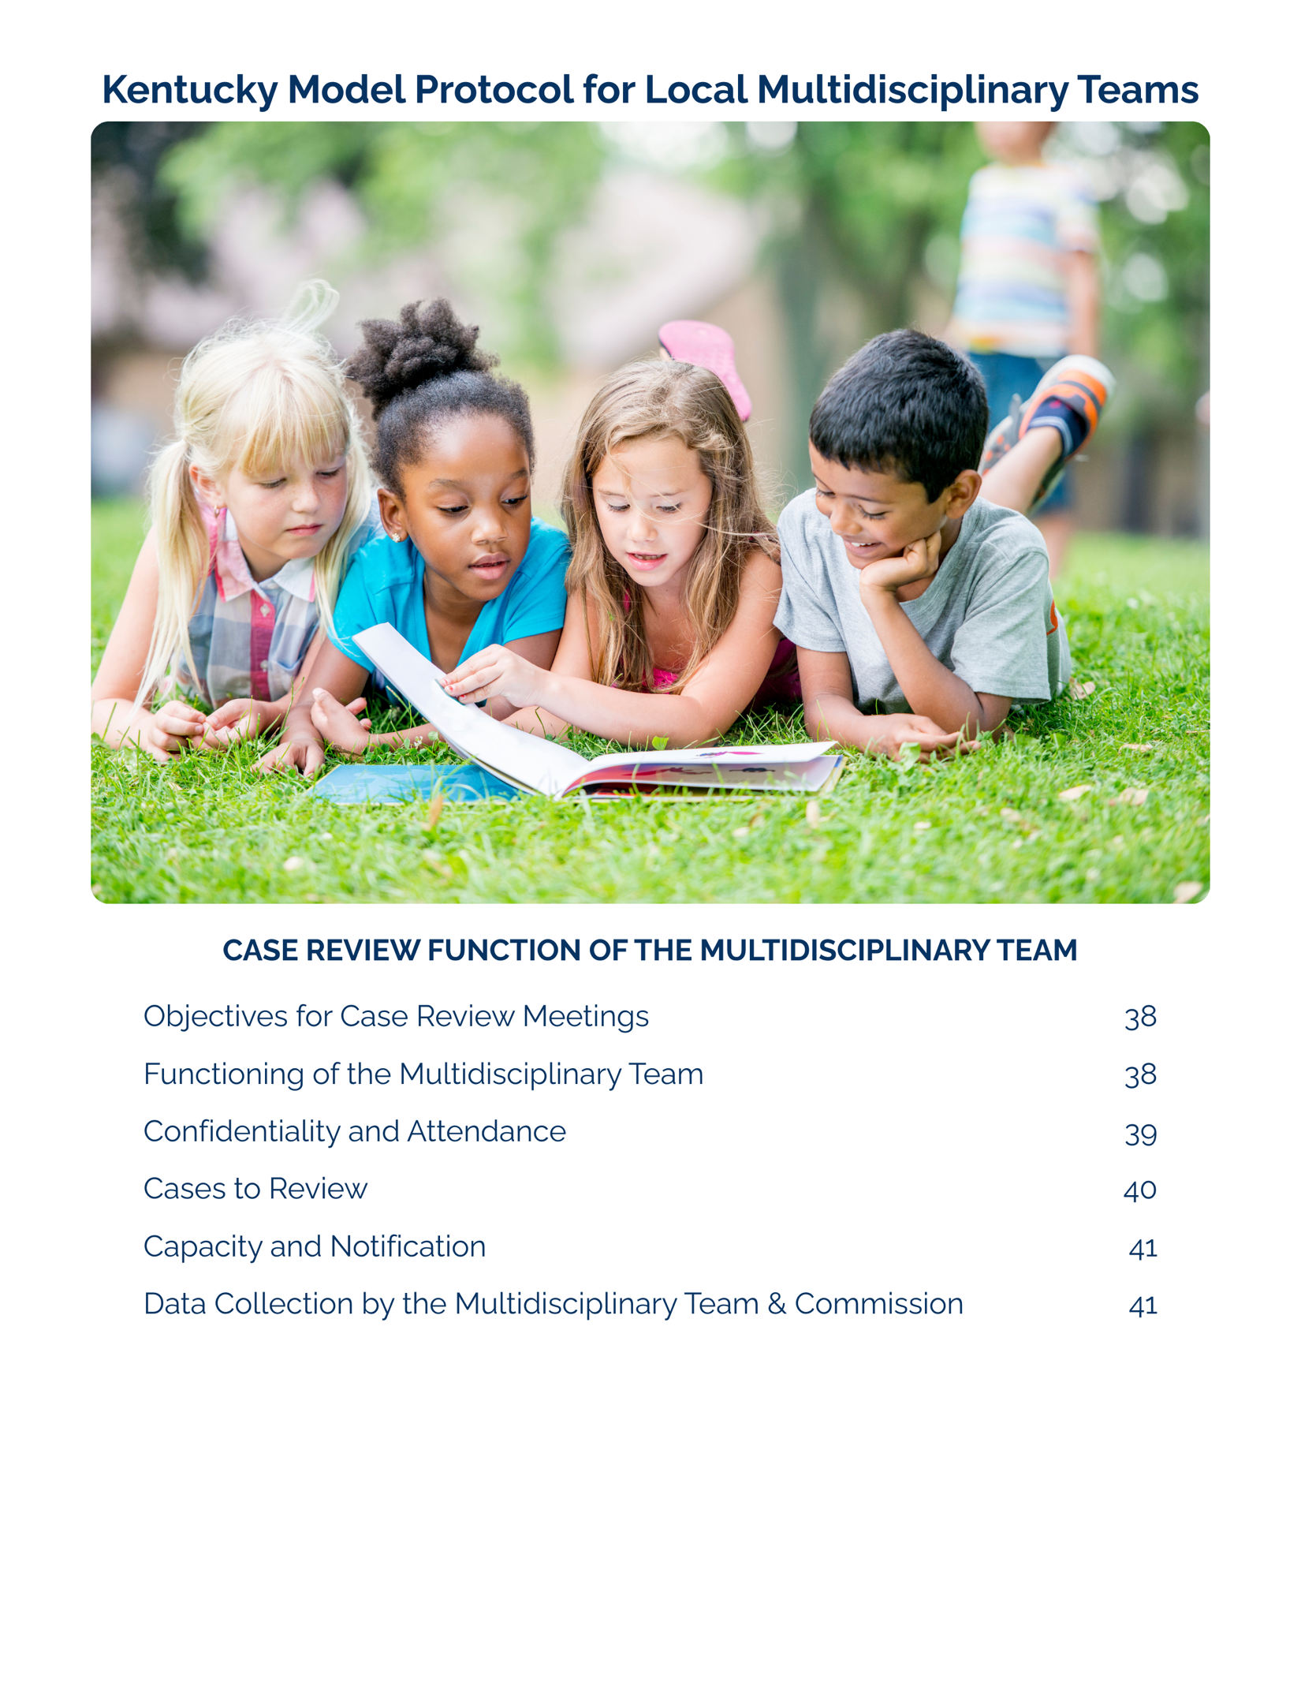

Case Review Function of the Multidisciplinary Team

Case review is a formal process that serves as a complement to ongoing case discussions and casework among the MDT partners focused on planning and monitoring current cases. Case review is central to a timely, effective, and coordinated response to child abuse, ensuring the needs of the child remain the primary consideration in all decision making.

Objectives of Case Review Meetings

In addition to other purposes, such as conducting investigations and improvement of the child abuse service system, meeting to review cases is an important function of the MDT.

Case review is designed to achieve the following:
- Coordinate the Response: ensure the most timely and effective system response by promoting a thorough understanding of case issues and monitoring the progress of investigation, intervention, and service delivery.
- Facilitate Communication and Information Sharing:
  - efficiently gather and share information and maintain clear communication among team members.
  - All participating agencies must fully cooperate in sharing information relevant to the abuse allegation, the child, and any involved persons to fulfill their respective statutory duties.
- Develop Coordinated Solutions: provide a forum for team members to voice opinions, develop joint solutions, and make appropriate case disposition.
- Assess and Monitor: coordinate interventions, assess the effectiveness of services, and facilitate efficient and appropriate case disposition.
- Address Concerns: allow any participant an opportunity to note concerns regarding case progress, coordination, protocol adherence or systemic issues within the MDT.

Functioning of the Multidisciplinary Team

The primary goal of the MDT is to provide ongoing assessment and monitoring to ensure the safety and well-being of children and caregivers.
- Collaborative Decision-Making: The process requires collaborative, informed decision-making, leveraging the distinct expertise of each discipline. Effective MDT work depends on the thoughtful consideration of case details through the lens of each team member's professional perspective and expertise.
- Shared Responsibility for Information: The success of the team requires shared responsibility for information transfer, always for the benefit of the child. Team members must discern and share information relevant to enhancing the team's decision-making process, doing so respectfully and with the sole intention of enhancing coordinated work. Confidentiality within the MDT is held collectively.

While the MDT process recognizes and respects the professional ethics related to confidentiality of each discipline when working in practice settings, confidentiality within the MDT is held collectively. Each member holds specific knowledge related to each child served that contributes to the goal of the MDT. Participation in the MDT requires each member to ascertain what information is relevant to enhancing the decision-making process of the team to meet the overall goals. Sharing of information should be done respectfully with the intention of enhancing the coordinated work of the MDT. All efforts should be made by all members of the MDT to participate with this goal in mind, both in formal and informal communication.

Confidentiality and Attendance

Information shared at Case Review meetings by MDT members and/or any invited attendees shall be kept confidential, including the identity of the victim and source of the report.

- Confidentiality Acknowledgment: All team members and attendees must sign a confidentiality statement consistent with statutory prohibitions on disclosure.
- Attendance:
  - Only core team members may attend the entire case review process.
  - Other professionals involved in a specific case may be invited to attend the relevant portion of a meeting, at the team's discretion.
  - Learners directly connected to the MDT's work, such as practicum students reporting to a member of the MDT and candidates for the SANE P/A credential completing their clinical competencies, may attend at the team's discretion, provided they sign and abide by the confidentiality acknowledgment.
- Conflict of Interest and Direct Involvement: A team member shall not participate in the review or discussion of any case where they are a direct party to the case (e.g., the victim, alleged perpetrator, or a subject of the investigation). Furthermore, if a team member has a personal or professional relationship outside of the investigation that presents any other real or perceived conflict of interest, they are responsible for immediately informing the other members of the team. The team will then determine the appropriate course of action (e.g., mandatory recusal from that portion of case review).

Cases to Review

The MDT must review all cases meeting the criteria identified in this Model Protocol and the Team’s Local Agreement.
- Review Schedule: The MDT will review cases at least monthly.
- Timeline: Cases should be regularly reviewed from the initial report through all court proceedings (criminal and/or dependency, neglect, or abuse). Cases without court action are reviewed until all involved agencies close the case and the team determines all case review objectives have been met.
- Presentation: All MDT members are expected to initially present their new cases and provide updates for ongoing case review.
- Timeliness: All qualifying cases must be brought to review as early in the investigation as possible to allow for time-sensitive recommendations.
- Presentation Information: Case presentations must include:
  - names of investigating law enforcement officer(s) and DCBS worker(s)
  - name and age of victim(s), name of the alleged perpetrator, and allegations or charges.
  - information needed for meaningful discussion may include (but is not limited to):
    - review of forensic interview outcomes
    - discussion, planning, and monitoring the progress of the investigation
    - review of medical evaluation findings
    - discussion of child protection and other safety issues
    - input for prosecution and sentencing decisions
    - discussion of emotional support and treatment needs of children and family members and strategies for meeting those needs
    - assessment of the family’s reaction and response to the child’s disclosure and involvement in the criminal justice and/or child protection systems
    - review of criminal and dependency/neglect/abuse case updates and ongoing involvement with the child and family as well as disposition
    - provisions for court education and court support and accompaniment
    - ensuring that all children and families are afforded the legal rights and comprehensive services to which they are entitled
    - discussion of how the MDT intervention is impacting the child and their family, including positive changes and challenges
    - child well-being and outcomes

Capacity and Notification

The MDT must review all qualifying cases.
- Capacity Limit: If the number of reported cases exceeds the capacity for review or there is another extenuating circumstance, the team must petition the Commission for review and resolution.
- Notification: Each team must develop a confidential process to notify team members of the cases scheduled for review, ensuring the identity of victims and alleged perpetrators is protected.

DATA COLLECTION BY THE MULTIDISCIPLINARY TEAM & COMMISSION
Each Multidisciplinary Team will provide the Kentucky Multidisciplinary Commission on Child Sexual Abuse the following annually:
- The information will be on the operation of local multidisciplinary teams, including non-identifying case information on cases reviewed by the MDT.
- Annually the Commission will prepare a report on the state of the multidisciplinary teams in the Commonwealth, which may include the information provided by local teams.

This report is separate from the Prosecutors Advisory Council (PAC) report that Commonwealth’s and county attorneys are required to complete. This report is one way to meet the requirement to provide an annual report to the public of nonidentifying case information to allow assessment of the processing and disposition of child sexual abuse cases and child human trafficking cases involving commercial sexual activity.



Privileged Communications and Confidentiality

Kentucky law provides for the confidentiality of records and case information that will be reviewed and discussed by the team.

Multidisciplinary team members and anyone else invited by the multidisciplinary team to participate in a meeting shall not divulge case information, including information outside of the MDT process, regarding the identity of the victim or source of the report. Team members, including members of the Kentucky Multidisciplinary Commission on Child Sexual Abuse and others attending meetings, shall sign a confidentiality statement that is consistent with statutory prohibitions on disclosure of this information.

All professions should be aware that there are circumstances through the judicial process through which records that are typically confidential or privileged can be compelled to be released.

Cabinet for Health and Family Services- KRS 620.050(5)

The report of suspected child abuse, neglect, or dependency and all information obtained by the Cabinet or its delegated representative, as a result of an investigation or assessment made pursuant to KRS Chapter 620, except for those records provided for in KRS 620.020(6), shall not be divulged to anyone except:

(a) Persons suspected of causing dependency, neglect, or abuse;
(b) The custodial parent or legal guardian of the child alleged to be dependent, neglected, or abused;
(c) Persons within the Cabinet with a legitimate interest or responsibility related to the case;
(d) A licensed child-caring facility or child-placing agency evaluating placement for or serving a child who is believed to be the victim of an abuse, neglect, or dependency report;
(e) Other medical, psychological, educational, or social service agencies, childcare administrators, corrections personnel, or law enforcement agencies, including the county attorney's office, the coroner, and the local child fatality response team, that have a legitimate interest in the case;
(f) A noncustodial parent when the dependency, neglect, or abuse is substantiated;
(g) Members of multidisciplinary teams as defined by KRS 620.020 and which operate pursuant to KRS 431.600;
(h) Employees or designated agents of a children's advocacy center;
(i) Those persons so authorized by court order;
(j) The external child fatality and near fatality review panel established by KRS 620.055; or
(k) The Commonwealth Office of the Ombudsman established pursuant to KRS 43.035.

Any person requesting disclosure of information pertaining to a client’s case record follows the procedures outlined per open records request and disclosure of information (per HIPAA). This pertains to both custodial and noncustodial parent(s) requesting information regarding their child’s case.

Children's Advocacy Centers

Kentucky law also provides that the records of CACs are confidential. Specifically, KRS 620.050(6)(a) provides that files, reports, notes, photographs, records, electronic and other communications, and working papers used or developed by a CAC in providing services under KRS Chapter 620 are confidential and shall not be disclosed except to the following persons:

- Staff employed by the Cabinet, law enforcement officers, and Commonwealth's and county attorneys who are directly involved in the investigation or prosecution of the case;
- Medical and mental health professionals listed by name in a release of information signed by the guardian of the child, provided that the information shared is limited to that necessary to promote the physical or psychological health of the child or to treat the child for abuse-related symptoms;
- The court and those persons so authorized by a court order;
- The external child fatality and near fatality review panel;
- The Commonwealth Office of the Ombudsman established pursuant to KRS 43.035;
- The parties to an administrative hearing conducted by the Cabinet or its designee in accordance with KRS Chapter 13B in an appeal of a Cabinet-substantiated finding of abuse or neglect. The children's advocacy center may, in its sole discretion, provide testimony in lieu of files, reports, notes, photographs, records, electronic and other communications, and working papers used or developed by the center if the center determines that the release poses a threat to the safety or well-being of the child, or would be in the best interests of the child. Following the administrative hearing and any judicial review, the parties to the administrative hearing shall return all files, reports, notes, photographs, records, electronic and other communications, and working papers used or developed by the children's advocacy center to the center.

Nothing in KRS 620.050 shall prohibit a parent or guardian from accessing records for his or her child providing that the parent or guardian is not currently under investigation by a law enforcement agency or the Cabinet relating to the abuse of a child.

Nothing in KRS 620.050 shall prohibit employees or designated agents of a children’s advocacy center from disclosing information during a multidisciplinary review of a child sexual abuse case as set forth under KRS 620.040(8). Persons receiving this information shall sign a confidentiality statement consistent with statutory prohibitions on disclosure of this information. Multidisciplinary team members and anyone invited by the multidisciplinary team to participate in a meeting shall not divulge information discussed during case reviews, including information regarding the identity of the victim or source of the report. Finally, employees or designated agents of a CAC may confirm to another CAC that a child has been seen for services, and, if an information release has been signed by the guardian of the child, a CAC may disclose relevant information to another CAC.

Mental Health

Statutes related to privileged communication between mental health professionals and clients are noted below. Privileged communication statutes found within the Kentucky Rules of Evidence (KRE) compel mental health team members to acquire releases of information from clients to allow the professional's full participation in team discussions. Consent for information to be released to the team may be included as part of a mental health agency's overall consent for treatment form. Consent for information to be released may also be requested by law enforcement or social services agencies that secure release of information signatures from appropriate parents or guardians. In extreme cases, court orders may be required to allow the professional to release needed information.

Finally, privileged communication does not prevent mental health professionals from reporting child abuse to the DCBS as is required by KRS 620.030. This includes the initial report of abuse and any subsequent acts of abuse against the child that are known or suspected by the mental health professional. Privileged communication statutes for mental health professionals include the following:

Counselor - Client Privilege --
The Kentucky Rules of Evidence provide a privilege for counselors within Kentucky Rule of Evidence (KRE) 506. A counselor is defined to include a school counselor, a sexual assault counselor, a licensed marriage and family therapist, a certified art therapist, a certified professional counselor, an individual who provides crisis response services as a member of a community crisis response team, a victim advocate as defined in KRS 421.570 (except a victim advocate employed by a Commonwealth's or county attorney), or a certified fee-based pastoral counselor.

A communication between a counselor and a client is "confidential" if not intended to be disclosed to third persons other than those present to further the interest of the client in the consultation or interview, persons reasonably necessary for the transmission of the communication, or persons present during the communication at the direction of the counselor (including members of the client's family). A client has a privilege to refuse to disclose and to prevent any other person from disclosing confidential communications made for the purpose of counseling. Exceptions to the counselor client privilege include:

- If the client is asserting his or her physical, mental or emotional condition as an element of a claim or defense; or, after the client's death, in any proceeding in which any party relies upon the condition as an element of a claim or defense; or
- If the judge finds that the substance of the communication is relevant to an essential issue in the case;
- If the judge finds that there are no available alternate means to obtain the substantial equivalent of the communication; and
- If the judge finds that the need for the information outweighs the interest protected by the privilege. The court may receive evidence in camera to make findings under this rule.

Psychotherapist-Client Privilege
The Kentucky Rules of Evidence provide a privilege for psychotherapists within Kentucky Rule of Evidence (KRE) 507. A communication between a psychotherapist and a client is "confidential" if not intended to be disclosed to third persons other than those present to further the interest of the client in the consultation or interview, persons reasonably necessary for the transmission of the communication, or persons who are present during the communication at the direction of the psychotherapist (including members of the client's family). A psychotherapist is defined to include a licensed or certified psychologist, licensed clinical social worker, a registered nurse, or licensed physician engaged in the diagnosis or treatment of a mental condition. A client has a privilege to refuse to disclose and to prevent any other person from disclosing confidential communications made for the purpose of diagnosis or treatment of his or her mental condition. Exceptions to this privilege include:
- In proceedings to hospitalize the client for mental illness, if the psychotherapist in the course of diagnosis or treatment has determined that the patient is in need of hospitalization;
- If a judge finds that a client, after having been informed that the communications would not be privileged, has made communications to a psychotherapist in the course of an examination ordered by the court, providing that such communications shall be admissible only on issues involving the patient’s mental condition; or
- If the client is asserting his or her mental condition as an element of a claim or defense; or, after the clients' death, in any proceeding in which any party relies upon the condition as an element of a claim or defense.

HIPAA Guidelines

Federal HIPAA guidelines may apply to data collection/submission if the entity submitting the data is a "health care provider." It is recommended that any agency concerned with meeting HIPAA requirements contact a person with expertise in this area.

Family Educational Rights and Privacy Act

Educational institutions are subject to federal and state laws regarding the release of educational records. It is recommended that educational system representatives consult with their legal counsel for an understanding of any exceptions that may apply related to investigations of child abuse.
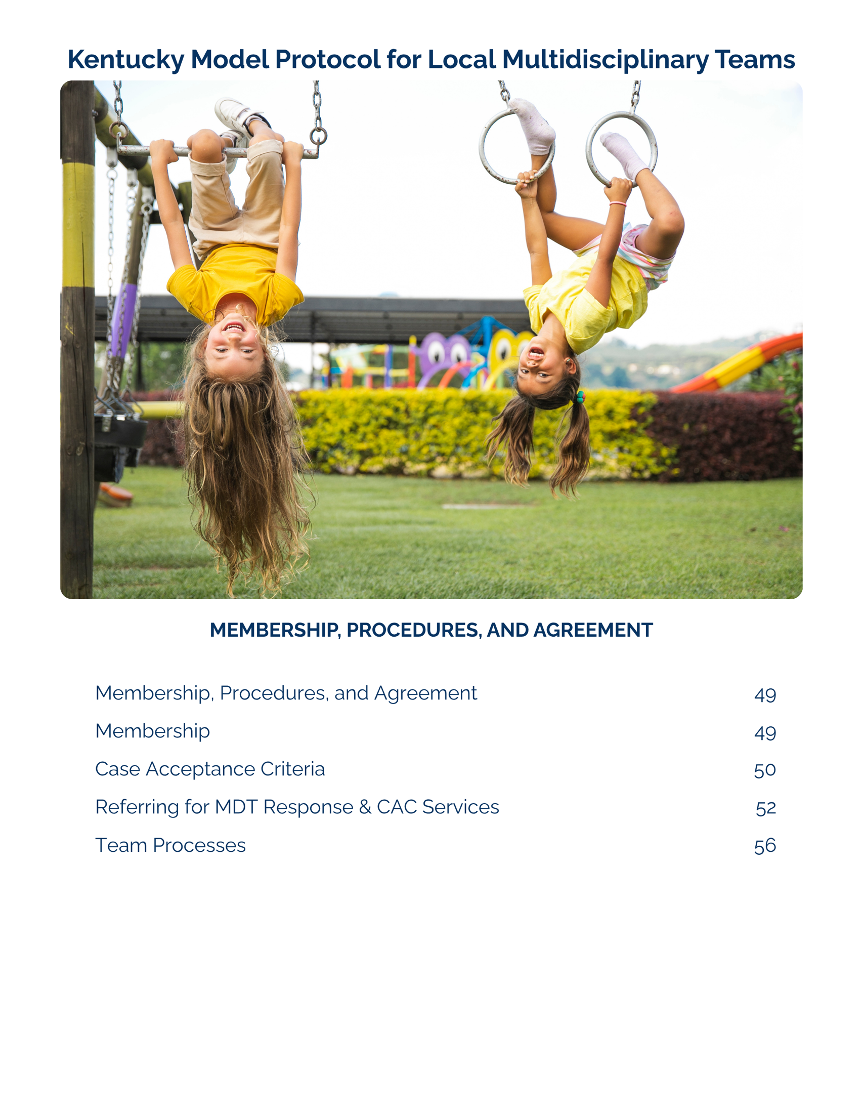

Name of MDT- Examples 99th Circuit Multidisciplinary Team or Sample County Multidisciplinary Team Membership, Procedures, and Agreement

Membership
The following agencies agree to serve as the local multidisciplinary team (MDT) and to follow the Kentucky Model Protocol for Local Multidisciplinary Teams (Model Protocol), which is supportive of a trauma-informed multidisciplinary approach being utilized in the investigation, assessment, medical/mental health treatment, and referral for prosecution for cases involving child victims of sexual abuse, human trafficking, female genital mutilation, and other cases the team identifies in this Local Agreement. It is expressly understood that each agency works within its statutes, regulations, and policies and that nothing contained herein supersedes the statutes, rules, or regulations of each agency when in conflict.
The team agrees to review the model protocol and these local procedures annually.

NAME OF AGENCY OR ORGANIZATION | DISCIPLINE
 | Commonwealth’s Attorney (Prosecution)
 | County Attorney (Prosecution)
 | Law Enforcement
Cabinet for Health and Family Services/
Dept. for Community Based Services
 | Children’s Advocacy Center
 | Mental Health Provider
 | Victim Advocate
 | Medical Provider
 | Education Professionals (optional)

Non-participating Law Enforcement
The team acknowledges that the following law enforcement agency operates within the team’s jurisdiction and that this agency does not have the capacity to investigate reports of child abuse. This agency has not responded to a case of child abuse in the prior year. Their leadership has been contacted by a member of this local MDT, and their leadership has confirmed that if presented with a case of child abuse, they have a process in place to request response from a law enforcement agency participating in this agreement.

NA or list non-participating law enforcement agencies here.

Case Acceptance Criteria

The team recognizes the benefits of working together and agrees that the following criteria will be used in providing a coordinated team response as follows.
The multidisciplinary team shall review child sexual abuse cases and child human trafficking cases involving commercial sexual activity referred by participating professionals, including those in which the alleged perpetrator does not have custodial control or supervision of the child or is not responsible for the child's welfare. The purpose of the multidisciplinary team shall be to review investigations, assess service delivery, and to facilitate efficient and appropriate disposition of cases through the criminal justice system.

The local team agrees that additional cases may benefit from the MDT response, as documented below.
MDT RESPONSE | Cases Required by Statute | Other Cases Agreed Upon by Team | Other cases referred at the request of a team member
Joint investigation & MDT case review | Reported or suspected child sexual abuse; human trafficking involving commercial sexually activity | Add local criteria here, if applicable. For example, if your team agrees to provide a joint investigation and MDT case review for every child fatality case, list that here. | Add local criteria here, if applicable. For example, if a team member can request a case involving a child witness to homicide, list that here.

The local multidisciplinary team must determine the acceptance criteria for services that may be needed to complete the investigation. The team agrees to utilize forensic services as listed below.

Forensic Service | Minimum requirements | Other Cases Agreed Upon by the Team | Other cases at the request of a team member
Forensic interview at the CAC | When practicable, reported or suspected child sexual abuse; human trafficking involving commercial sexual activity; female genital mutilation | Add local criteria here, if applicable | Add local criteria here, if applicable
Medical Exam at CAC or through formal agreement/ other qualified provider | See Medical Exam section of the protocol, following the guidance of the Kentucky Child Sexual Abuse Medical Protocol 502 KAR 12:010 | Add local criteria here, if applicable | Add local criteria here, if applicable

Child victims and their non-offending caregivers often need support during and after an investigation. The local MDT commits to providing access to victim advocacy and mental health services as listed below.

Victim/Family Support Service | Minimum requirements | Other cases at the request of a team member
Victim advocacy per the coordinated victim advocacy flow chart | A child and their non-offending caregiver involved in a joint investigation/ MDT response should receive victim advocacy. | Add local criteria here, if applicable
Trauma-focused mental health services | Any child who is involved in a joint investigation/ MDT response and is identified as experiencing trauma related mental health symptoms, whether identified by a team member or a non-offending caregiver, should receive mental health services. | Add local criteria here, if applicable

Referring for MDT response and CAC services

MDT Response and Case Review
The above criteria have been established for cases that will receive an MDT response and be reviewed by the local multidisciplinary team during case review meetings. While all members of the MDT are responsible for following the Model Protocol and the Local Agreement, the CAC routinely facilitates communication between law enforcement, child protective services, and prosecution to promote the MDT response, including case review. Position/Title of the CAC is responsible for coordinating day-to-day information sharing and case coordination for the team.

The responsible party for preparing the list of cases that meet the criteria for review on behalf of the team is Position/Title of Agency or Organization Name. All investigative team members are responsible to ensure that cases that meet criteria are included for review by providing information about any new cases before the meeting or during the meeting. Any team member may request that a case be added to the review. Describe the process for SECURE distribution of the case review list.

The facilitator of the case review meeting is Position/Title of Agency of Organization Name and is responsible for facilitating inclusive, comprehensive discussions of all cases and for communicating recommendations and any necessary follow up to MDT members in a timely manner.

Multidisciplinary team members and anyone invited by the multidisciplinary team to participate in a meeting shall not divulge case information, including information regarding the identity of the victim or source of the report. Team members and others attending meetings shall sign a confidentiality statement that is consistent with statutory prohibitions on disclosure of this information.

Medical evaluation
In cases of reported sexual abuse, investigators will contact the CAC first for consultation and/or to schedule a specialized medical examination. This communication is critical to avoid multiple medical examinations. Medical provider name or entity will be utilized as a source of qualified medical input to aid in the referral process and the identification of how, when, and where the exam is made available, in addition to following the model protocol. This communication is critical to provide the most appropriate and best quality medical care. Add information here about availability of local medical services and how to reach the CAC after hours. More than one agency/ provider can be identified. Identify which provider(s) provide acute exams, non-acute exams, and attend case review meetings.

Forensic Interviewing

To the extent practicable and when in the best interest of a child alleged to have been abused, interviews with a child shall be conducted at a children's advocacy center. Forensic interview referrals may be requested by law enforcement, child protective services, and/ or prosecution. A child advocacy center cannot interview a child if the allegations giving rise to the referral have not been reported to child protection and/ or law enforcement. Add who must be present to observe the forensic interview (minimum of one investigator but can be more detailed here). Add the process for contacting the CAC for emergent forensic interviews. Add how to access a recorded interview here (not the copying statute). If applicable, add statement about remote live observation of interviews.

Victim Advocacy

Referrals to the CAC for medical evaluations and forensic interviews will include a referral for CAC advocacy services. Victim advocacy services may also be appropriate for children not referred for other CAC services. Add information here about how to refer for advocacy.

Advocacy services must be coordinated between advocates from multiple agencies if multiple advocates are involved.

Coordinated Victim Advocacy Flowchart
When multiple agencies are providing advocacy services, teams need to add specifics as to which agency provides which portion of the advocacy response. Coordination of advocacy services is essential to avoid duplication of services and confusion for child victims and their non-offending caregivers. Below is a flow chart demonstrating coordinating services with up to four advocates throughout the life of a case. Use this flow chart as a reference. Edits may be made to reflect any differences in the Local Agreement of the team.

Before the interview
CAC Advocate | Community Advocate | Law Enforcement Advocate | Prosecutor Advocate
Orient the family to the CAC  Get consent forms signed  Participate in the pre-interview meeting with the team | May sit with the child while CAC advocate completes intake and consent forms with the caregiver  May participate in pre-interview meeting | May sit with the child while CAC advocate completes intake and consent forms with the caregiver  May participate in pre-interview meeting | May participate in the pre-meeting with the team

During the interview
CAC Advocate | Community Advocate | Law Enforcement Advocate | Prosecutor Advocate
Assess needs with caregiver  Provide appropriate referrals for mental health services and medical exam for the child  Provide written information for the caregiver with names of the professionals involved in the case and community referrals provided  Provides information about victim compensation and victim rights | May sit with the caregiver/ family  May provide information about victim compensation and victim rights | May sit with the caregiver/ family  May provide information about victim compensation and victim rights | May observe/ meet the family  May provide information about victim compensation and victim rights

After the interview
CAC Advocate | Community Advocate | Law Enforcement Advocate | Prosecutor Advocate
Participates in the post-interview meeting to discuss next steps  Finish any paperwork and offer Outcome Measurement Survey to caregiver and/ or child | Remind family of community advocate follow up as it relates to any services needed | Explains to family they will be in contact regarding status of the law enforcement investigation, if applicable | Explains to family they will be in contact regarding status of investigation, if applicable

MDT Case Review
CAC Advocate | Community Advocate | Law Enforcement Advocate | Prosecutor Advocate
Report on any contact with family since the forensic interview  Update team on status of medical, mental health, and other referral made to the family  Relay any questions/concerns of the family to the team | Provide updates to team, if release signed by family | Discuss contact with family regarding status of the investigation | Discuss contact with family regarding status of the investigation  Provide information on family’s wishes about prosecution

Charges not filed
CAC Advocate | Community Advocate
Conduct follow-up calls with family to ensure all needs met for community services | Conduct follow-up calls/ coordination of advocacy services as necessary

Charges filed
CAC Advocate | Community Advocate | Law Enforcement Advocate | Prosecutor Advocate
May accompany family to court proceedings | May accompany family to court proceedings | May accompany family to court proceedings | Provide ongoing contact with caregiver to discuss court process  If case going to trial, coordinate court preparation for child and family  Discuss family’s wishes and victim impact statement  Provide court accompaniment  Provide any post-conviction notifications
Adapted from Victim Advocacy Flowchart, Northeast Regional CAC, November 2019

Team Processes

Case review meetings
Case review meetings serve important functions, including the assessment of service delivery and facilitation of efficient and appropriate disposition of cases through the criminal justice system.

Team members are committed to attend case review in order to support the rich discussion necessary to fulfill those functions.

Every discipline on the MDT offers expertise that cannot be duplicated by another discipline. For the purposes of this protocol, the professionals attending represent their discipline of expertise. For example, while a victim advocate may be employed by a prosecutor’s office, a law enforcement agency, or a community mental health center, the attendance is for their expertise as a victim advocate, not as a prosecutor, a law enforcement officer, or a mental health provider.

The team will meet add the day, time, location, and/or format. If there is a temporary change in the meeting, identified individual's title/ entity will notify team members at least 2 business days in advance of the new meeting day and time. If the team decides to change the meeting date, time, location, and/or format for the foreseeable future, the team must notify the Commission via email (KMCCSA@ky.gov), in lieu of submitting a revised protocol.

Team orientation

The CAC will provide an orientation for new multidisciplinary team members to introduce them to the purpose, functions, and processes of the team. Orientation will include, at a minimum, information about:
• team member roles and expectations
• coordinated investigations
• process for referrals
• review of local services
• multidisciplinary team members’ names and contact details
• Kentucky Model Protocol, including the local membership and procedures
• case review logistics (time, location, frequency)
• CAC Code of Conduct
Add local process for providing this orientation. Include who is responsible for providing the orientation, when the training should occur, where the orientation will occur.

Accessing CAC Records
The CAC provides access to aggregate data (not case specific information) for program evaluation and research purposes to MDT members upon request. For MDT members to gain access to the information and data, the team member or agency should contact the CAC staff member title/ role to request the information to be shared. Data may include number of children served, age, gender, investigation type, type of abuse, and services provided.
For MDT members to access case specific information, Provide local process here. Example: MDT members’ requests to review a recorded forensic interview or to access written case file may be made to the forensic interviewer or victim advocate assigned to the case. All information provided is subject to applicable confidentiality protections under Kentucky and/or federal laws, including but not limited to those considerations outlined in the Model Protocol.
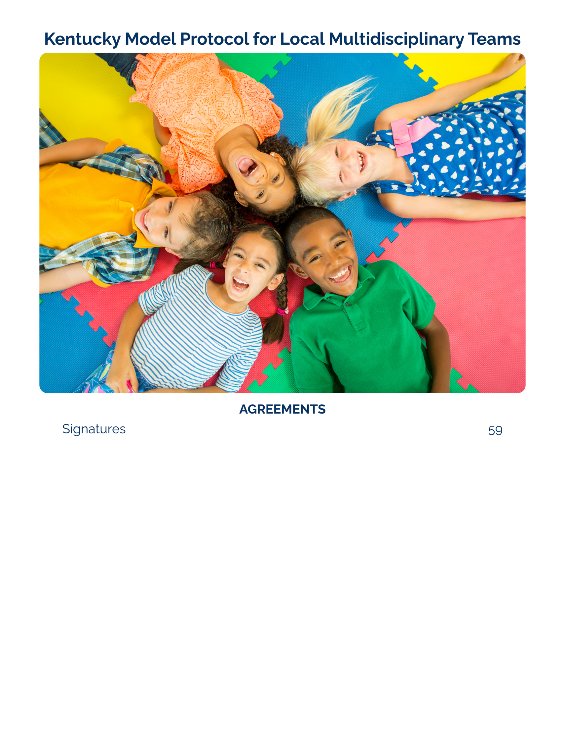

Signatures

This protocol must be signed, at a minimum, by leadership from the respective member agencies as listed below. Additional representatives who participate in the MDT response for each agency are also encouraged to sign the protocol. Each signature must contain a typed name and title, as well as the date. Electronic signatures are acceptable. Additional signature pages may be added as necessary.

This instruction page may be omitted from the protocol.

Commonwealth Attorney
Elected Commonwealth Attorney
County Attorney
Elected County Attorney
Law Enforcement
Kentucky State Police- Captain of the involved Post/ Posts
Sheriff’s Departments – Elected Sheriff
City Police Departments – Chief
Other Police Departments – Chief
Cabinet for Health and Family Services
Service Region Administrator
Children’s Advocacy Center
Executive Director
Victim Advocate
Executive Directors of victim advocate program(s)
Mental Health
Administrator for the employer of the qualified clinician and/or the clinician
Medical Professional
Administrator for the employer of the medical professional(s) and/or the medical professional
Education System
Administrator for the educational system representative

Commonwealth’s Attorney/ Prosecution Agreement

The undersigned hereby agrees to follow the Kentucky Model Protocol for Local Multidisciplinary Teams and the attached Local Membership and Procedures for a coordinated, multidisciplinary response to child abuse.

Agency: Copy from list of team members

___________________ Commonwealth’s Attorney
Signature Name Title Date
__________________ Asst. Commonwealth’s Attorney
Signature Name Title Date

(For additional signatures, please add signature, printed or typed name, title, and date. If no additional signatures, delete this box.)

County Attorney/ Prosecution Agreement

The undersigned hereby agrees to follow the Kentucky Model Protocol for Local Multidisciplinary Teams and the attached Local Membership and Procedures for a coordinated, multidisciplinary response to child abuse.

Agency: Copy from list of team members

___________________ County Attorney
Signature Name Title Date
__________________ Asst. County Attorney
Signature Name Title Date

(For additional signatures, please add signature, printed or typed name, title, and date. If no additional signatures, delete this box.)

Law Enforcement Agreement

The undersigned hereby agrees to follow the Kentucky Model Protocol for Local Multidisciplinary Teams and the attached Local Membership and Procedures for a coordinated, multidisciplinary response to child abuse.

Discipline: Law Enforcement

Agency: Copy from list of team members

___________________
Signature Name Title Date
__________________
Signature Name Title Date

(For additional signatures, please add signature, printed or typed name, title, and date. If no additional signatures, delete this box.)

Department for Community Based Services Agreement

The undersigned hereby agrees to follow the Kentucky Model Protocol for Local Multidisciplinary Teams and the attached Local Membership and Procedures for a coordinated, multidisciplinary response to child abuse.

Agency: Copy from list of team members

___________________
Signature Name Title Date
__________________
Signature Name Title Date

(For additional signatures, please add signature, printed or typed name, title, and date. If no additional signatures, delete this box.)

Children’s Advocacy Center Agreement

The undersigned hereby agrees to follow the Kentucky Model Protocol for Local Multidisciplinary Teams and the attached Local Membership and Procedures for a coordinated, multidisciplinary response to child abuse.

Agency: Copy from list of team members

___________________
Signature Name Title Date
__________________
Signature Name Title Date

(For additional signatures, please add signature, printed or typed name, title, and date. If no additional signatures, delete this box.)

Victim Advocacy Agreement

The undersigned hereby agrees to follow the Kentucky Model Protocol for Local Multidisciplinary Teams and the attached Local Membership and Procedures for a coordinated, multidisciplinary response to child abuse.

Agency: Copy from list of team members

___________________
Signature Name Title Date
__________________
Signature Name Title Date

(For additional signatures, please add signature, printed or typed name, title, and date. If no additional signatures, delete this box.)

Mental Health Provider(s) Agreement

The undersigned hereby agrees to follow the Kentucky Model Protocol for Local Multidisciplinary Teams and the attached Local Membership and Procedures for a coordinated, multidisciplinary response to child abuse.

Agency: Copy from list of team members

___________________
Signature Name Title Date
__________________
Signature Name Title Date

(For additional signatures, please add signature, printed or typed name, title, and date. If no additional signatures, delete this box.)

Medical Professional Agreement

The undersigned hereby agrees to follow the Kentucky Model Protocol for Local Multidisciplinary Teams and the attached Local Membership and Procedures for a coordinated, multidisciplinary response to child abuse.

Agency: Copy from list of team members

___________________
Signature Name Title Date
__________________
Signature Name Title Date

(For additional signatures, please add signature, printed or typed name, title, and date. If no additional signatures, delete this box.)

Education System Agreement

The undersigned hereby agrees to follow the Kentucky Model Protocol for Local Multidisciplinary Teams and the attached Local Membership and Procedures for a coordinated, multidisciplinary response to child abuse.

Agency: Copy from list of team members

___________________
Signature Name Title Date
__________________
Signature Name Title Date

(For additional signatures, please add signature, printed or typed name, title, and date. If no additional signatures, delete this box.)

Agreement

The undersigned hereby agrees to follow the Kentucky Model Protocol for Local Multidisciplinary Teams and the attached Local Membership and Procedures for a coordinated, multidisciplinary response to child abuse.

Discipline: Other-specify or N/AOther – specify

Agency: Copy from list of team members

___________________
Signature Name Title Date
__________________
Signature Name Title Date

(For additional signatures, please add signature, printed or typed name, title, and date. If no additional signatures, delete this box.)

KRS 431.600(2); 431.660(1)(b)
KRS 620.040(8)
KRS 431.600; 620.040(8)(c)
KRS 620.040(8)(c)
KRS 600.020 (1)(a)(10); 508.125 Note: While female genital mutilation is not explicitly required to be reviewed by local MDTs in statute, mutilation is covered under the state’s definition of “abused or neglected child,” and the Commission identifies mutilation as a form of sexual abuse.
KRS 620.030(1)
This list is not exhaustive and should include allegations of both completed and attempted acts.
Professionals responding to child abuse may be impacted by secondary traumatic stress. Resources for professionals are found in Appendix A.
See KRS 620.040(8)(b)
KRS 620.040(8)(c), (d), (f)
KRS 620.030
KRS 15.725(1)
KRS 15.725
KRS 15.727
KRS 15.706(2)
KRS 431.600(3)
KRS 431.600(4)
KRS 431.600(5)
KRS 431.600(6)
KRS 431.600(7)
KRS 431.600(7)
KRS 421.510
KRS 421.500(6)
KRS 421.520
See KRS 524.040 or 524.055 for definitions
KY Const §26A and KRS 421.500-.575
Unified Juvenile Code KRS Chapter 600 et seq.
KRS 431.600(1)
KRS 620.020(4)
KRS 431.600
KRS 620.040(1)(d)
KRS 600.020
KRS 431.600(1)
KRS 620.040(3)
See KRS 620.060
KRS 610.125(2)
KRS 610.125(1)
KRS 620.030(7)
KRS 16.128
KRS 421.500(3)
KRS 620.040(5)(c)
KRS 620.020
922 KAR 1:580
KRS 620.040(7); 431.600(8)
See Appendix B for a resource on working effectively with interpreters.
KRS 620.050(10)
KRS 620.050(10)
KRS 214.185
See definition of advanced medical consultant: National Children’s Alliance (2023). National Standards of Accreditation for Children’s Advocacy Centers.
See Appendix C for resources regarding suicide assessment and prevention.
KRS 15.760(6); 69.350 (relating to victim advocates hired by Commonwealth's attorneys and county attorneys, respectively, if applicable); KRS 421.570
Defined in KRS 421.500
Section 26A.
KRS 421.500-575
KRS 158.4416
KRS 156.496
KRS 158.4416
KRS 431.600; 620.040
KRS 620.040(8)(f)
KRS 620.040(8)(e)
KRS 620.040(8)(f)
KRS 620.050(7)
KRS 620.050(8)
KRS 620.040(8)
KRS 620.050(9)
KRS 160.720; 20 U.S.C. 1232g – Family educational and privacy rights
KRS 620.040(8)(c)
KRS 620.040(8)

