19-ORD-136

July 10, 2019

In re: Gerry Lawson/Jefferson Circuit Court Clerk

Summary: Decision adopting 98-ORD-6 and holding that because Jefferson Circuit Court Clerk is not bound by the provisions of the Open Records Act, the Clerk did not violate the Act in the disposition of request for court records.

Open Records Decision

This matter having been presented to the Attorney General in an open records appeal, and the Attorney General being sufficiently advised, we find that the Jefferson Circuit Court Clerk is not bound by the provisions of the Kentucky Open Records Act, and therefore cannot be said to have violated the provisions of the Act by failing to respond to Gerry Lawson’s request for copies of court records. We believe that 98-ORD-6, a copy of which is attached hereto and incorporated by reference, is controlling.

A party aggrieved by this decision may appeal it by initiating action in the appropriate circuit court pursuant to KRS 61.880(5) and KRS 61.882. Pursuant to KRS 61.880(3), the Attorney General shall be notified of any action in circuit court, but shall not be named as a party in that action or in any subsequent proceeding.
Andy Beshear
Attorney General

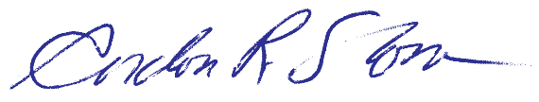

Gordon Slone
Assistant Attorney General

#271

Enclosure

Distributed to:

Gerry Lawson, #294518
David L. Nicholson, Jefferson Circuit Court Clerk

